

Bank of England

Inflation Report

November 1993

Inflation Report

November 1993

Recent price developments

.1 Retail prices

1.2 Output prices

*Domest*ic deflators

Summary

*Reba.ring and revisions—how ha.s*

*d?*

1. Monetary and fiscal policy 1 0
   1. Monetary conditions 10

Interest rates

Exchange rates 14

Fiscal policy 14

2.3 Suznmo

*MO’s monitoring range*

Demand and output Demand

Personal spending

Investment and stockbuilding 18

Overseas trade 20

3.2 Output and the output gap 22

1. Summary

*CSO trade figures.- new collection methods*

The labour market 25

Earnings and settlements 25

4.2 EmplpyFtet

I tt mls • I2£lmployment 25

kBb0ttf PT8dl2CtiYfty and inijf yJtgg

costs 27

28

Price dynamics 29



External influences 29

Primary product prices

Overseas inflation and import prices 30

5.2 Input prices 30

.3 Business profitability Summary

1. Prospects for inflation
   1. Evidence from financial markets
   2. Private sector forecasts 34
   3. Surveys of inflation expectations
   4. Bank projections 36

The short-run outlook 36

Longer-term projections 36

Uncertainties 38

39

Pinted by BurrupsL‹d.$ilvcsplc

0 Ban8 t›t' England 1993 IS8N I g0730 (142 4

**Summary**

The *Inflation Report* considers recent developments in inflation

.and puts forward the Bank of England’s analysis of future prospects. It contains seven sections covering:

1. recent price developments;
2. monetary and fiscal policy;
3. demand and output;
4. the labour market;
5. price dynamics;
6. the prospects for inflation; and
7. conclusions.

Underlying inflation efined as the twelve-month change in the Retail Prices Index excluding mortgage interest payments (RPIX)—has risen since the last *Inflati.on Rej›ort.* It was 2.8% in June. but has increased in each of the last three months, to reach 3.3.% in September.! The headline rate of inflation has also risen.

RPIX inflation has been affected by the switch from the Community Charge to the Council Tax. To disentangle the impact of such tax changes .on the price *level* from the ‘underlying’ rate of *inflation,* it is useful to examine a price index which excludes not only mortgage interest payments but also indirect taxes and local authority taxes. Inflation measured in this way rose from 2.8&o in tune to 3.5& in September, the same as a year ago befote sterling’s depreciation began to affect .import prices.

8ome increase in inflation between.June and September had seemed likely at the time of the last *Report.* Sales discounts were unusually widespread in June, suggesting that a rise in the inflation rate would follow post-sale price rises. In addition, seasonal food prices, fell by more than is usual in June.

IN fact, RPIX inflation has risen a little more than projected last time: !:to 3.3&:compared with, 3.l.%. This .difference panty

3

reflects smaller than:expeeted falls .in. food pric.es in July, and.. partly the larger than expected recovery...in. the.prices..of\household goods and clothing and footwear:aSSOciated with!ihe.end of the summer sales.

To conduct monetary policy effectively, .it is..necessary..to! form a

view about the likely .course of iñflatioh over the longér tern, "

Given current policies, the Bank’s view of the .most likely outturn is that inflation—both headline anti RPIX—will rise .until the middle of 199.4 and then start.!to .decline again. The new information avai!lable since the August *Aepo*rr has led to a! small

.upward revision in tire.twelve-month inflation rates expected over. the next few months, but it has not produced any!significant change .to the expected rate of inflation two years from now. Tne central projection remains within the target range for **RPIX** inflation. But there is a slight possibility that in the first iialf of’ next year inflation will briefly rise above,the top of the target range. This is partly because of changes in indirect and local authority taxes. Excluding those .taxes, inflation.is .expected to start falling in early 1994, and could reach a level close .to,’the middle of the target range in 1995.

But there are considerable uncertainties. The first concerns .the exchange rate. If attempts to stimulate recovery lead to bigger than expected cuts in interest rates abroad, this would be likely to push up the sterling exchange rate and reduce!inflationary pressures in the short run.

.A second source of uncertainty is the behaviour of wage bargainers. If the short-run increase .in inflation is simply extrapolated forward and. earnings start to .ri.se .more rapidly; them

.more of the growth of nominal ldemand which is exp.ected over the next year or two will take.the form of higher prices rather tlian higher output and employment. .But the continuing output gap,

.moderate growth of nominal .deman‹i,.arid slow growth. in ñroad money an‹i credit, all point to the possibility of bringing.inflation down further.at the same time as o.utput. growtti.,pic.ks! up.

 

### J Ret ce

.Underlying infl tion—defined as the twelve-month change in the Retail .Prices Index excluding mortgage interest payments (RPIX)—has risen since the last *Inflation Report.* It was 2.8D in June but has increased in each of the last three months to reach 3.3% in



.September (Chart 1.1). The headline rate of inflation



*has allo risen.* Three months *ago it had* falJen to 1.2%, " the lowest rate for nearly 30 years, but by September it

had increasled to 1.8%.

, Headline inflation has been lower than RPIX inflation  since the middle of 1991. The difference between it and

* • RP/X primarily reflects changes in mortgage interest "“ payments during the previous twelve months. The gap
  + will narrow in the next few months as the reductions in interest rates which took place last autumn fall out of the

' twelve-month calculation.



**Tsfi1e›1.A**

**'Contrliiutions to RPIX inflation**



sona

During the course of this year, RPfX inflation has been affected by the switch from the Community Charge to the Council Tax. The change lowered the twelve-month rise i!n RPIX, an.effect which will persist until the second quaner of next year. At that point the increase in VAT announced in the March Budget will .enter the index. To!disentangIe the impact of such tax changes on the price *level* .from the ‘underlying’ rate of *inflation,* it is useful! to examine a price index which excludes not oqly mortgage interest payments but also indirect taxes (VAT and excise duties) and local authority taxes.

Chart 1,1 shows inflation measured in this way—

the beginning of 1990. RPIY inflation.rose from 2.8% in June to 3.5% in September, the same as a year ago before sterling’s depreciation began to affect import prices.



Some increase in both RPIX and RPIY inflation between June and September had seemed liitely at the time,of the, last *Report.* Sales discounts were unusually widespread in June, particularly for clothing and tontWRdf,..suggesting that a rise in the inflation rate would,follow p.ost-sale, price rises. .In addition, seasona l ***foDil*** prices fell by more than is.usual in June.

**Able’1.A shows** that these **two** factors accounted for

full ation Repos: November 1993

most of.the rise in inflation between:.June and Sleptember.

Tuhle 1,B

**Short-run** measures of inflation











Charl 1.2

Prtiducer **output price** inflation



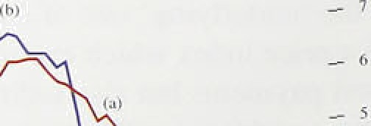



Short-run inflation measures can ,often give an early indication, of a change in inflation: Table l.i3 shows. tire three-month inflationlrates for.a iiuinber of indices. The figures have been .seasonally adjusted and annualised, to allow comparison with conventiofial twel*e-month measures. Short-run measures need ,to be interpreted with particular care in order to distinguish ch;inges in the. normal séasonal pattern ‘(such as.the early start of summer sales in June), from persistent.changes in the i.n.flation rate. The.table shows that,:fol1owing. a sharp fal.I .i.n ihort-run RPIX. in.flation .between. March and June

as a result of the introduction of the Con'ncit Tax, the rate. reb’ounded to 4.5% in September.

Table l.A shows the.main changes to, the componénts.of

.RPIX inflation since sterling left the exchange rate mechanism in.September 1992. .RPIX.inf1ation,fell by 0..7 percentage points: during.this period. But if the i.mpact of the switch. from the Com!munity Charge:to the! Counei.l. Tax..is remov.ed,..the. inflation. rate was broadly

.uneha!nged. Within the totâl. the contribution of.services to inflation has tended to .‹ii!mi nish anñ that of goods has , increased. .Petrol, clothing. an‹i footwear, and seasonal foods are all contributing significantly.!more. For petrol. and.clothing.and footwear,.this reflects the impact of depreciation .on lmpon pricles. ..By contrast„,re@i1

non-seasonal food prices contributed no more to in.Elation during the past year.than!i;n lhe!year before. sterl!ing’s withdrawal .from the ERM, despite sharp .rises in farm.gate prices caused, ñy a. net devaluation of.the ”green poun0.

2 O e

Manufactiired.output prices:ha:ve acc:elevated.si:nce tlie last *Inflation Répof..* In!the year to 3epteñiñer, piices.

.rose:by 4.20, up from.4.0:% in:the year..to June. The

:mafiiifacturing:sec.torihas.been redefi!ned b.y tlie CSO since the last.?teport,.arid' the price series has..also been debased.to..al!ow for:changes 1in: the comp9sition of

 



outp

.page 7).. The.new series, liich now irieludes pQtr.oleuin.

.:refiiiing,. shows that output prices rose more slowly.

‹iuring the! pnst two1.yeñrs’:than ivhen they!,were metmeil

.by the!.ol‹i series (Chart 1.2)... But it!a1so means that:the: rate of increase of ptices has: risen,.since a year ago,:a

.chaiige. Ulrich was less obvious in ilie **eai1!iér** data:

 



The UK.national.accounts statistics have ricently! fieen debased on the year 1990. This!means tiiat all the expenditure coñiponents of **GDP df6 nO.W** expressed in terrors of av gg 1990 prices and new aggregate measures have been *cat* mutated. Similarly, tlie detailed components of.outputs Ulrich weie- previously weighted together!i:sing 1985. values for net ouijiut, have now been.rewei.ghtéd according.to valaes of net output in 1990. Together with other data revisions and inethodological-changes, rebasing alters rmorded histoJ.

Br.eakdcwn uf *money' GD.P grnn’th

Pcrceni e c.hangc

potential'output and its defilatiotiary i!ri1pact.may now. be.smal:ler. Real GDP. (at factor:.cost) is. now. thought to have risen by 2.One in tire.yeñr to, 1993. Q2, compared .with.a previous estimate! of l.5&. Tire recovery appears.steadier,.rising yenthy. *tMough* 1952, increasing less rapidly âroiind the. turn.of;the

y•

Manufacturing on its réviséd definiiiofi it now includes!coke, oveas, mineral processing..and: nuclear fuel productiori has:grown more lslowly sinée the beginning of. this year.tfiâii.onginally recoided. lii the!’first.six.,months of 1993

’Money'’ GDP Rcul GOP

:baxc. box

Dén esiic



manufactunn$ output is.estirriated fo! ave Brown ñy

1.59o, compared with ,âii!.earlier estimate!.of 2.7ho,





1990 .Q l —



i 993 Q 2  

The.table details the ou!tput.an!â prire romponents of mñoney **GD.P** growth ifi'the United.Kingdom. over the past four yeârs or so,!on the new anfi old bases. The

This downward revision to manqfacturing output. largely reflects a reassessment.of”the:inovement of prices and volumes i:n this!1sector:: ln paniéular; export prices, whicfr have grown.sh

autumn following. the fall in the exchange.rate, ate now included in the deflator. used ›to derivel ‘real’ output. .As a result, .estimated volume growth .in this period has been reduced.



fall in infiatioii is now estiImated to! have been a By contrast, sei’vice sector output .has.been..revised littld less: This is offset.by.a higher estimate of real up, both through the period .of recession **and.in** the growth... ,Since the trough.in output, which.is now subsequent upturn. On the 1990 ñased fiata;:total esii.mated.to.,have.been. in 1992 Ql;..J9& of the services output—which. accounts.for 63%! of GDP increase in money **GDP** derived from price is back above its recent peak at’ the.beginning of’ increases.. This comp;ires..with ñ! &...ove.r.the:same 1990; on the old base‘it was '/:•% bélow this peak..



At tñe siine.time, with stronger. recovery now

:evidént, the..output’ga the gap between actuai,.and:

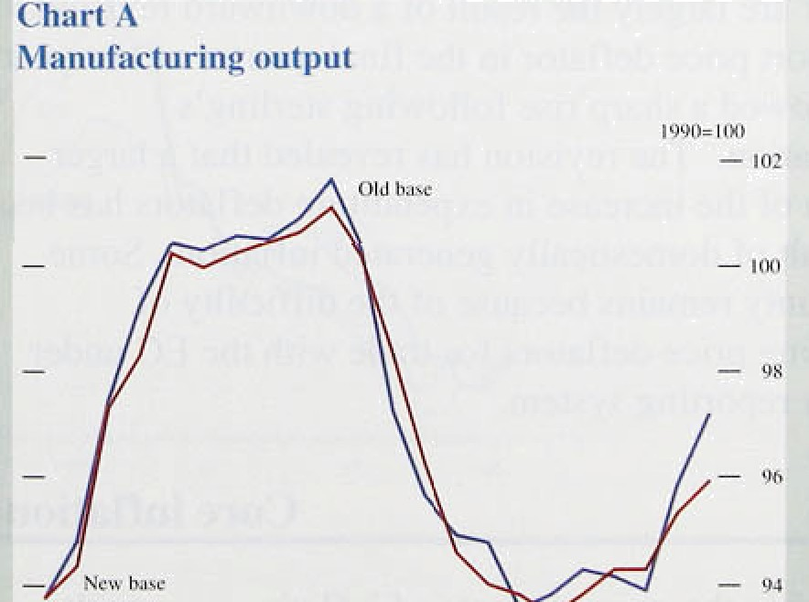

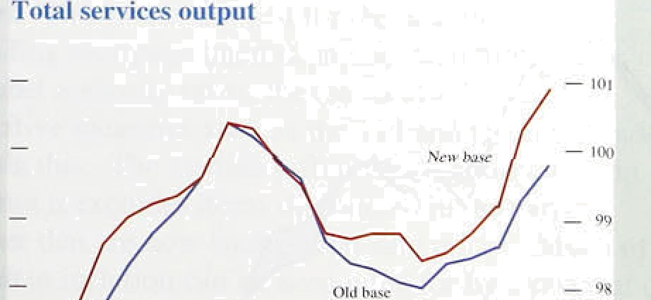

!nflRtiun Rego«: November I9vñ

Chart I..3

i’vIanufacturing export and producer price inflation





_ is



91 92 93



rerccniagc ch aagcs .on z year carl ipr

—' 12





if!the.more.: volatile..prices.of petroleum.refining, aii;t food, driiik,and tobacco, are exc1u‹ied, .the!rate:.of increase:of output pnces is a little:hi:gher than tliree rñonths ago: In the yeâr to September, prices rose by 2.9&o,.up. from 2:4to in. the year to June.. Moreover,.iri the .latest.three months, pnces have nsen at an annua!ise:d rate of:3.7T•..

Some rise in .the .rate of'i'ncrease of producer output ’’ prices during 1993,had seemed .likely at .tlie tiñ›e of last autumn's depreciation. Chait 1.3 shows that, .although manufacturers' prices! in.the. home market haye nsen by slightly less than 3% over the:past,year, .the sterling prices for manufacture‹i exports to tlie non-EC economies have risen by 'more..than. l4fio, during w!hlch time. sterling fell by,a similar lamount against the non-EC currencies. Both the speed and the extent to which export prices have .responded are surprising.! Past experience suggested that export!prices woiild. rise by only ablout hal.f the extent of'the devaluation.

## Domestic deflators

The .GDP deflator provides a:ñroader measureeof domestically generated i!nflation.. Tñis series too.has been affected by the rebasing of tlie'n’ational:accounts since the last */Report:* The;hew data.show that the factor cost GDP ‹ieflator (which exoludes indirect taxes and subsidies) was unchanged between -the first and secodd quarters of t1iis:year. !:In the year\to Q.2, tlie .deflator rose

.by I.5%. This was much.lower.than i.n the year to Ql ; that increase is now put at 3.1 „against the 2.0&! that was reported iir August (see Chart 1’.4):

The higher estiinates of the increases in the recent **GDP**

deflator are largely the.result of a downward revision ,to

.the import price fieflator in tlie fina1:q,uarter of last year. This !showed a sharp rise following sterling's.! depreciation. The revision...has reveale;i titiit a larger fraction.of the..increase i!n.expendi!turi 'deflators..has.been the result ofe‹iomestically generated inflation. Somie uncertainty remains because, of.the,difficulty of‘

.estimating price deflators for trade with the! EC under

.the.nqw!reporting system:

### 1.4.

Changes, i!n the measured’.rate of.inflation can. result

.from movements in relative prices as well as from. changes in iiriderlyiñg.inflation. But it fs not always easy .to. distinguish relatiye price.movements from

Itecent *price d*m'e*l*opm*e*n*is*

chaiiges.in the general price level; hence the divelopment of indicators that try to identify ‘core' inflation.

Most "core’ .inflation measures tackle the problem of **relative price** movements by eKcJuding particularly volatile prices. The example .in Chart 1.5 (which excludes food and energy.as well as mortgage interest payments and taxes) is typical. But it is also possible to construct measures with clearer theoretical foundations.



* + - The median inflation rate, which also appears in Chart I.5, was discussed in detail in both the May and August
* *Repocts.* It excludes .the effect on headline inflation of ‘large changes in relative prices. As the chart shows, the
* .median inflation rate tracks RPIX inflation reasonably 1closely over .much of its range, but indicates a further small fall in inflation since June.

Chart 1.6 shows two other useful measures: the housing

.!a‹ijusted (HARP index) RPI and the Tax and Price Index (TFU. The..HARP index has an estimate of the user cost of housing .in place of mortgage interest payments (and was ,discussed in the February *Ripon ).* On this measure, inflation has risen more steeply, partly because house prices rose.over the last twelve months (whereas interest rates, whicli affect headline inflation, fell). The Tax and Price Index is an index of the gross taxable income needed for!tax payers to maintain their purchasing power; it i.ncreases if direct tax rates or the RPI increase. The TPI has followed the RPI closely, reflecting the absence of substantial direct tax changes in the last twelve months.



1 5 Su

Inflation is a little higher than at the time of the August

*Re"p!or.t..* This is:true not just”for the headline rate. Excl'udi rig mortgage interest payments, indirect taxes and local authority taxes. the rate is also higher, and



’alternative meastires lsuch as the TPI and the **HARP** index cohfirm th:is. Tlye .median inflation rate shows a slight fall.. But it.exc1!udes! items. discounted in the early suminer that are: now.fiack at .non-sale prices. M.uch of the rise in.inflatioq .can be accounted,for by a.reversal of

*.*di*sc.*oti*’*ti*ts staNi*ng in lime, *p1us,a* .return to a more normal gaEern! of'seasona1 food prices:

9



Chart 2.1

Twels’r-month growth rates of CIO, hI4, Divisia and the credit counterpart to M4

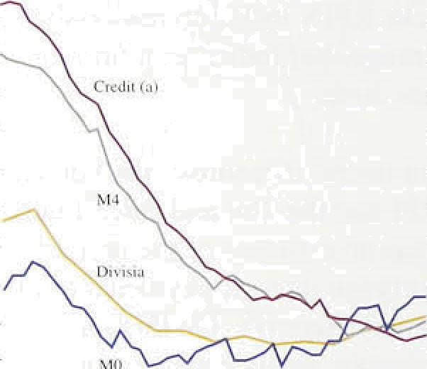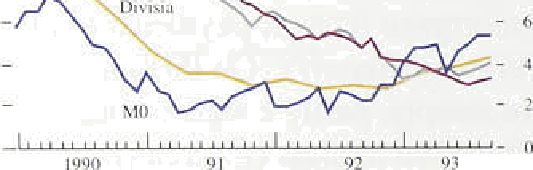

‹ a i Bank and h\Wilding *ocic4y leading In the private *c I ›r.

Chart 2.2

Twelve-month growth rates of notes and roin and s'aIue and volume of retail .sales

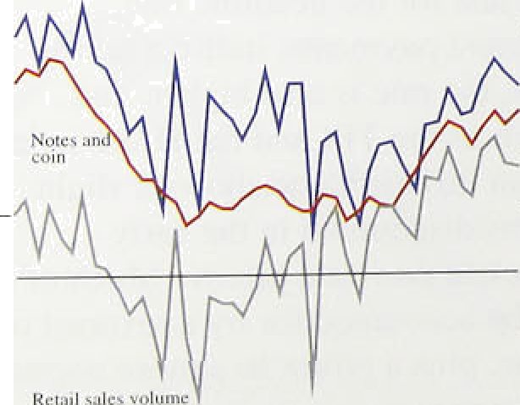

-

2

### 2 oneta co

The grow.th..of both.narrow and.broad:money has risén. slightly.since,the last be Sothe monetary aggregates are showing a greater degree of consistency than was the case in the first half of this year. .However, .M0.remains well..above!the..top of its 0%—4% monitoring range and M4.remains near.the bottom of its range.



The .monthly changes in MO continue to ,be erratic, but the general direction since the last fi*eport i* one of faster growth. The provisional twel!ve-month rise ,i.n October was 5.4%, the highest.since Ju!ly 1.990. Some of tfiese monthly fluctuations in M0. can be attributed to. movements in bankers" balances, !but the provisional. demand for notes. and cot.n alone (a better indicator.of underlying narrow rrioney) has, also accelerated to, 5.3fi•. Notes. and coin are.a goo‹i and timely !guide for nominal demand growth, as reflected.in increases in the value of retail sales .(Chart 2.2). The twelve-month growth in the value of retail sales has averaged over file in recent months, lthe highest sustaine‹i growth since the middle of. 1990. Thetwelve-month growth.of notes and,coin is also the highest since that period.

A large part of the strength of M0 is attributable. to the. increas1e.in liquidity and the.reduction!.in velocity growth. brought about by lower interest.rates over the last year.

There; is uncertainty about the .precise!.size. of:the interest rate effect on M0 in the short:run. However,. over‘the medium term, the present monitorirrg range of 0éoN& for M0 remains: broadly:consistent .w!ith the inflatioñ target.(see the box on page 12).

Broad money growth.has picked up a:1.ittle,. its. twelve-month growth rate rising to 3.9&o.min..ltte third. qiiarter. The.annual growth rate!’of bad and bui:1ñing’



4 the main credit counterpart.to M also rose in the third quarter. Witji both. the :three and six-month annualised growth rates: of M4 and M4 lending aboVeAtmeir annual growth rates, thts.suggests that.tire trough in broad . money and cre‹ht growth may have been.reached in the



last..qqart er. JO. e Yer• th1§.B@fi § **I'll1l8,frOfii.811

already.low base’:

*Monetary and rel* c'*licy*

**Chart 2.3.**

**Ectimated total quarterly sterling** fiorrowing!.by





- 6





**'yP.r'*ate actor net s{erling ho*rowirig froip**





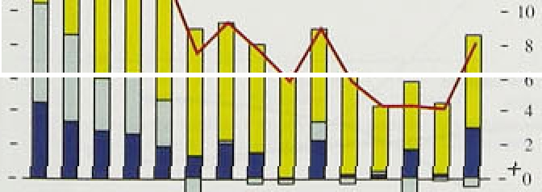

Receñt:work.by the Bank on the role. of banks and building.s1ocieties in the.transmission mechanism (see the article on pages 478—91 of this November’s *Quarterly Bulle!tin )* highlights .the significance of

.sectoral measures of money and credit. Empirical evidence suggests that the characteristics of the demand for both money and credit (bank and building society lending) vary sector by sector. firms (part of the ‘industrial and commercial companies’ grouping) are



.able to switch.both.their assets and liabilities relatively

:easily between banks and non-banks. Looking just at their bank deposits and b,orrowings will thus provide only a partial,.and possibly misleading, view of their finaneial decision-making and thus of their potential spendi!ng.

This is important when interpreting recent monetary trends. Industrial and commercial companies have

.repaid borrowing.from, banks and building societies in each of the last **three** quarters (see Chart 2.3). But at the same time companies have taken advantage of buoyant capital markets to issue shares and bonds: though capital issues were lower in the third quarter than in the secon‹i quarter, they were still higher than in any quarter last year. So the pattern of financing among industrial and com.mercial companies appears to represent balance sheet restructuring, rather than balance sheet contraction. They may be reducing bank debt either to increase the maturity of their liabilities through longer-dated bond issues, or to reduce their indebtedness more generally by increasing Equity capital. Neither is necessarily a harbinger of weak s



Credit from the banks and building societies constitutes a much larger proportion of the total liabilities of small firms. and households than of companies, because these

less able to draw upon the capital rriarkets for fun‹is. So!in, principle credit should provide a better indicator of the personal sector’s actual and potential.spehfiing patterns..



.Bank and! buildirig society lending.to the personal sector increased!.by £5.5 billion in.the third quaner, against

.fi4,2 bi1lion'in the second quarter (Chart 2.4). Wfthin

.this, lendiñg.for!hous.e purchase rose by £4.9 billion, from.£.4.3 billion in.the second.quarter, This is consistent:with'the.modest.recovery in activity in the housing market!....But lending for consumption remains broadly unchanged from the: second.quarter. The relatively:modest rise'in. borrowingtis, b.y .itself, probab.ly

.insufficient to aceount fully. for the recent fal.1s in the

personal aector saving ratio'. This .would tmply that

#### MO’s monitoring range

In the last Budget. fixed monitoring ranges were set for both M0 and M4 (0% to 4% and 3% to 9& annual growth respectively) for the whole period c‹ vered by the Medium Term Financial Strategy (until 1997/98). The Financial Statement and Budget Report contained an annex on MO’s monitoring range which described how M0 has recently been growing faster in relation to



nominal GDP than in the past. In other words. the growth rate of MO’s velocity of circulation h‹ts slowed (see the box on page 299 of the last *Qnarte i lv Bulletin ).* The annex noted that if th’is were more than a temporary phenomenon, MO's medium-term monitoring range might have to be changed. But further investigation of MO indicates that the current monitoring range may still be appropriate and consistent with inflation remaining within its target range over the medium term. Interest rates held at 69c over the medium term imply velocity growth of about 2.59c per annum in the medium term. So, for example, 4% MO growth could be consistent in the medium term with nominal GDP growth of about 6.5%, which accords with the real growth needed in the recovery and the inflation target.

But, in the short run, account must be taken of tempoi’ary effects on the demand for MO. An important example of this is the effect of changes in interest rates. Interest rates can have both temporary and permanent effects on the relationship between MO and nominal GDP. With lower interest rates, the cost of holding cash (the interest foregone) is lower. other things being equal. But low interest rates may also reduce the rate at which new methods of payment or of handling cash are introduced, because the benefit they bring—economising on the use of cash—is reduced. The permanent effects of changes in interest rates may cause the monitoring rnnge for the growth of MO that is consistent with the inflation target in the medium term to change.

Temporary effects, although not altering the

medium-term monitoring range, may change the current assessment of monetary **conditions.**

different M0 equations. The equations shown are the Treasury equation (from the January 1993 Public Release of the Treasury macroeconomic model) the current Bank of England equation (described in a forthcoming Bank of England working paper) an4 an earlier equation estimated by the Bank in 1989 (described in ‘The long-nin determination of the UK monetary aggregates’ *Bank of England Discussion Paper No. 41).* The estimates shown in the chart include only the direct effect of interest rates on M0 for a given level of nominal demand. The most noticeable feature of this chart is that the estimates of the short-run effect of interest rates on M0 vary greatly among the three equations. The Treasury equation predicts that after about five quarters a cut in interest rates can be expected to increase MO growth by over 0.8 percentage points whereas the earlier Bank of England equation predicts less than a 0.2 percentage point increase in M0 growth over the same period. The current Bank of England equation falls between these two, predicting an effect of just over 0.4 percentage points.

This range of estimates illustrates how difficult the interpretation of M0 growth becomes after a change in interest rates. In particular, these estimates do not give a clear indication whether the current strong growth of M0 is an indicator of loose monetary conditions or whether it is

result of simply a temporary change in the rate of growth ot the velocity ot circulation.





.T :a.0 sr ’6:o b:p



3.0,!,!. ;3.0 3.0 3.0 3.0.;'.



 



Chart 2.5

**Expected:French-Germsn, interest ra**te **differential •›.**

’" 0,5'

05

- 0.4

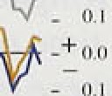

.individuals are financing a greater proponion of their

:spendi!n.g out of income, through .a slower accumulation of saxings: Partly, this wiI.l. be reflected in sluggish bank and'building society deposit growth. Equally, howe.ver, it inay the refJ ed in slower accumulation of non-bank

.assets, such as equities, which—unlike non-bank 'liabilities—make up a significant proportion of the personal sector’s balance sheet.



Borrow.ing by businesses rose by



£0:4 .billion in the th.i.rd quarter, following a net repayment of £0.8 billion in the first half of this year. If sustained, this rise ,in borrowing would suggest that the scaling back of these businesses’ liabilities has been completed. .Future income may be used for spending, rather.than to repay existing debts.

The Bank’s Divisia index rose by 1.19 in the third quarter, compared with an increase of 0.9% in the previous, quarter. On an annual basis its growth rate increased for the third consecutive quarter from its trough of 2.8% in the fourth quarter of 1992 and currently stands at 4.2%. Consistent with the signals given by the sectoral analysis, the growth in Divisia was largely related to personal sector activity. The personal sector index increased by I.39« in the third quarter, **‘raisihg** its annual growth rate to 5:09o—the highest since 1990 Q4. The corporate sector index, on the other hand, grew by only 0.5% and its annual growth rate fell

.further to I.1%—the lowest since 1985 Q3.

*lnte!rest rates*

Although.official interest rates in the United Kingdom

since the last *fiepprf,* rates in Continental Europe fell after the widening of the ERM bands on 2 August, though not by as much or as quickly as some were expecting. The Japanese discount rate .has als’o been reduced (see. Table 2.A). The European sequence, of changing expectations is best illustrated by



!changes in the differential. between French and German three-inonth interest!rate futures (Chart 2.5). The di:fferential in early August as the market expected large and rapid Erench interest rate cuts, but has since returned to lie above its level at the



.end of.J1ily. ,The.re‹iuction iq Germam interest rates on 21 Oetoher was followed by most other EC countries.

Markâ t!‘expñetations of the level. of UK interest rates at the..end of the. year fe!1 by two. thirds of: a percentage. point after the. wideiung,.of the ERM bands. The.market seemed to be expecting ster1!ing to appreciate;.thereby

I3

1Iifl;ttfon Report: November 199a

Table 2.B

offering.scope for:art interest.rate cut. .These.

Sterling exchange rates.

### expec o

f t ,«

|  |  |  |  |  |  |  |
| --- | --- | --- | --- | --- | --- | --- |
|  | t992 | I993_ |  | | | |
| Sicrlinp ER1 | 15 Sept.  90.90 | S Feb.  77.70 |  | 7 May  80.90 | 2 Aug  81.40' | 27_Ocf.  80.41) |
| Deurs«he Mark | 2.OR | 2.40 |  | 2.49 | 2.55. | t.49 |

### eded!as the

f i

pated.1arge

'

ductions.

La ly, however, inte t..rate ex ain the United

Kingdom have once.again.been lowered ñs dorriestie

data have been.interpreted as Snaking a monetary easing

in the B dget A h

he'

J ''

peocen "‘e 'oinecuf

now

**Chart 2.6**

Implied forward interest rates

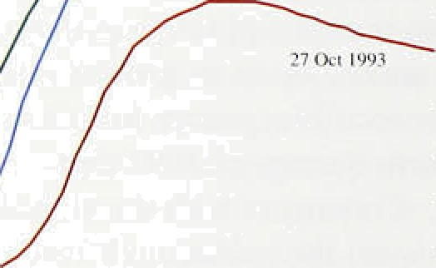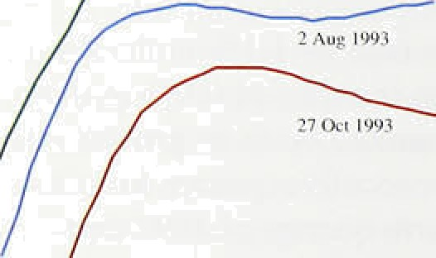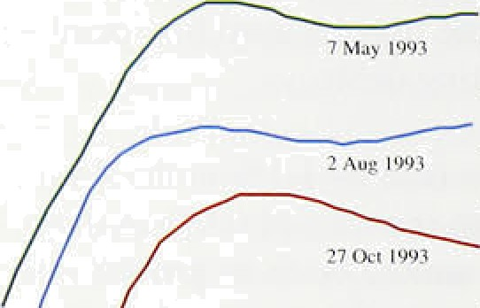

expected before the end of the year, with a .further ’(at most) half percentage.point.reduction expected in.!the . early pan of next year,

Consistent with thts, there .has. been.a.markeii:decline in implie‹i one-year forward fntereñt.ratest.(Chan:2:6).. (The box in.Section 6 of.the list.?tép*.or!t* explains:tlie method used to derive, these rates.) But no adverse effects have. been felt.!at the long end of the yield éiirve, with yields fall.ing to new lows, The yield curve! suggests that interest:.rates are e pected.to me to a peak of 8& :early next cetittiry-and then,decline ter a

plateau of 7'/i&o., These.levels are respectLvely‘around 60 and 100 basis points lower than.,at1the tirñe of ifie..last *Report.*

Chart 2.7

98 2£D2 06 l0



The effective exchange rate index .for sterling is.little changed since.the last Repo*rt,* .it stood at 80.4 on:

.27 October against 81.4 on 2 August (see Table 2!.B).

UK and trade-weighted world interest rate

**yield** curves ISeptember **1993)**

United Kingdom



Si.nce its suspension1from.the. **ERM** just over a, year ago, stealing has fallen by 11%.; the fa1l:against EC currencies has been fi.She and against non-ECicurrencies

16.5 r.

Previous *Reports* have coiiipared the short-term yield

.curvelfor the United Kingdom with that.for world interest rates. At the .time.of.the !last *fieport,the"* 0i.fferential between,.these curves. was.aroimd -0.52a

.for!three-month.interest rates.an‹i -0.13a» fpr

twelve-month rates. Si.rice then* the ‹differenti-als have

been reversed. UK rates stood at a premium of 0.!26&

.driving September at the twelxe-month. honzon!

(Chart 2.7). This. implies that the sterling effective index

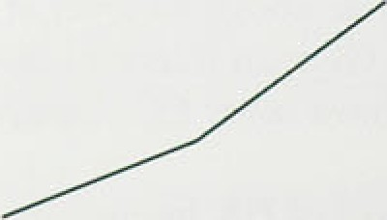

is expected to.depreciate shghtly over the next year:, conmpared with an expected.appsiation.at a« time of ’iJie {aft R,*epor{.*





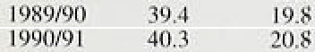

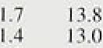 



I'.:2: I I'-8 ie:4 3.:8..



ydar.: The.current forecast, made at the time of the March B.udget,. is £50 billion. At the halfway point in

,the fiscal, year (taking account of the monthly outturns to end-September) both government expenditure and receipts, particularly those most directly dependent on economic activity, were broadly in line with the March forecast.,

In eash fiscal year since 1988/89, general government expenditure (‘GGE’) has increased as a proportion of GDP (Table 2.C). Over the same period, the public finances have moved from a surplus (of 3% of GDP in 19188/89) 1to an expected deficit of 8Tr of GDP in 1993/94. The share of current grants (which include social security payments and unemployment benefit) in spendi:ng increased during this period, reflecting the ‘automatic stabilisers’. Expenditure related to the general government pay bill has remained at around 30% of total expenditure throughout this period, but has increased as a of GDP since 1988/89; in 199!l/92 (the latest period for which data are available) it accounted for l2&o of GDP. The measures recently announced by the Government to limit pay rises in the public sector will reduce the public sector pay bill, as a proportion of lboth GGE and GDP.



Siricé 1=991/92 the public finances have .been in deficit and the value of outstan‹iing government debt has incre.ase‹i ,sharply, .albeit from a low base. In previous **periods** when the government has borrowed heavily, inflation was higher, and the real increase in government indebtedness was less (see the article on pages 512—20 of this November’s *.Quarterly Bulletin).* The five percentage point increase in the net debt to GDP ratio in 1952/93 was'exceptionally high by historical standards. In spite of tire measures announced in the l993/94

Budget, the, net debt to GDP ratio .is forecast by the Treasury .to increase by .a further 16 percentage points

.between **.1552/93** and 1997/98, although **its** rate of increase!.should decline.

iThe aiuiua1’ growth rates of both broad and narrow

!money; rose in the third quarter, although. M0 remains above **its monitoring range** and M4 re**mai.ns** close to the flo9r of its monitqiing range. The existi!ng monitoring ranges would seem.appropriate over a inedium-term

**llORZon.** iThe tefm s.tructure of interest rates-at both long and short.nuitutiiy has.!shifted,downwards. So opt cted,interest,'rate rn‹iucaon.s halve ñad no adverse

mP upon„longer-term:inf lation. expectations. The

continuing rapid increase in the ratio of public debt to GDP need not jeopardise this development, as long as the efforts of the Government to reduce the PSBR retain credibility.

3



The path‘ of.in.Elation..towards its long-run rate depends on ‹demand relative to the economy’s potential output

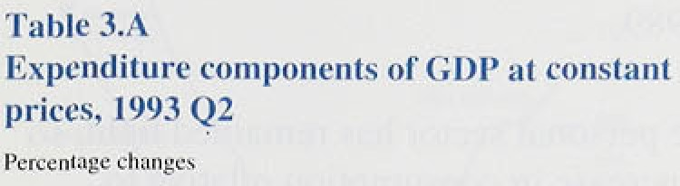.and on the!.demand for .labour.relative ro labour’ supply. This section exam1.nes the recent behaviour of aggregate demand to assess whether there will continue to lie down.win d pressure1 on the inflation rate in the short run.









GDP.fbl . .''0i6



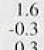

(+.-7



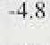

## Demand

The rebase‹i rigu.res on ..demand and output show a recovery from the trough in 1992 Q1, with quarterly growth averaging nearly hal)’ a percent (see the box on page 7), broadly .in line with. the trend in productive potential. The recovery so far has been evenly balanced between traded and non-traded sectors, ret’lecting the substitution of ‹domestic goods for imports and a recovery in ldomestic demand (Table 3.A). Net trade contributed half of the 2% rise in GDP between 1992 Q l afid 19.93 Q2, and.domestic demand the rest. A p‹›sitive

.contribu:tion of 1..4 percentage points from consumption duri.ng the period was part!y offset by a negative contribution from. investment and stockbuilding: goverrimenl consu:inption was flat.

**'Personal seCtor.saving and.,bnrrf›wing**



* Consumption turned up at the same time as GDP: in

- • .l.992 Q2 it ro’se for the first time in two years. Since then it.has increased slightly more slowly than GDP: by 1.6&o in the year to 1993 Q2, compared with a rise in

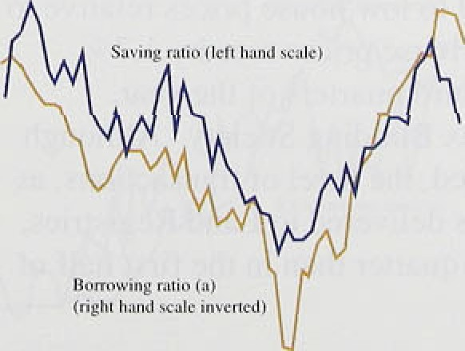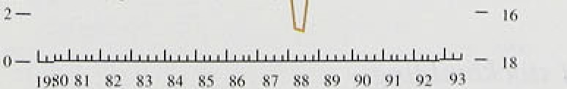

,

GDP:of 2.I).fin.. At first, the recovery in consumption also lagge0 beh!ind that .in real.personal disposable incomes (RPDI). so that1..the. savings ratio rose, ter I 3..3°Zc in 1992 Q3 (slee Chart 3.1). since then, RPDI has fallen.

Income from wages and. salaries. now comprising just ovér’half'of.personal income, barely rose between the fi:rsE £trld second quarters.

**Since’then,** retail sales have remained buoyant: in the thlrti quarter’; volurfies were



previous,three inontlis an‹i 3.8%.above the 4’ame per irid a year bef9re. .The strongest componen.ts have been sales of durables”fparticularlyihousehold goods) which in the latest three months! were..9:2% higher .than. in.the same pgnocl last year.

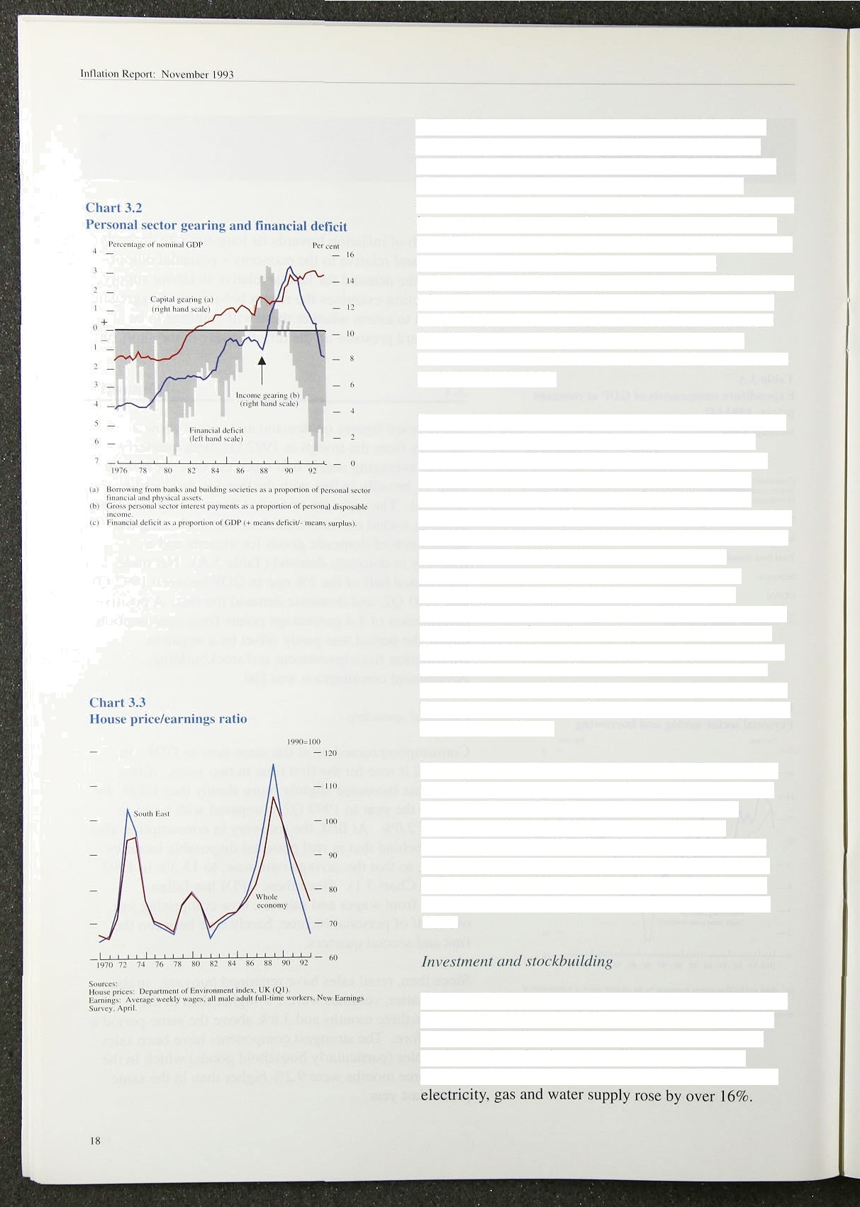The fall in the savings ratio to 10.1 No fn 1993 Q2 has reflected stronger consumer confidence: the Gallup index has improved from a low of -26.3 in 1992 Q4 to

-8.6 in 1993 Q3. The rise in confidence probably reflects reduced income gearing (brought about by lower interest rates), better employment prospects, and some stability in the housing market. The sharp fall in interest rates since sterling left the ERM last year has substantially eased the squeeze on the disposable income of indebted households, while reducing the income of households with net financial assets. Chart 3.2 shows that the income gearing of the personal sector has returned to the same level of the mid-1980s and is about half its peak in 1989.

Borrowing by the personal sector has remained light, so that most of the increase in consumption relative to income has been financed by a fall in personal sector assets. This is unusual: in the past. changes in the savings ratio have been associated with changes in consumer borrowing (Chart 3.1). The likely explanation for the current anomaly is that many households are still heavily geared, while others have accumulated substantial assets. People are still cautious about borrowing, with capital gearing close to its peak

(Chart 3.2) and the housing market still weak. They are particularly cautious about mortgages (which account for almost 80% of total personal sector borrowing), and the fall in interest rates has made financial assets less attractive compared with goods. However, there was an increase in consumer credit in August, apparently linked to purchases of cars.

The housing market appears to be responding at last to lower interest rates and to low house prices relative to earnings (Chart 3.3). House prices rose by 1.7% between the first and third quarters of the year, according to the Halifax Building Society. Although activity remains subdued, the level of transactions, as indicated by particulars delivered to Land Registries, was higher in the third quarter than in the first half of 1993.

**Since** total investment stopped falling in 199 I Q3, it has fluctuated within a narrow range around l59r of GDP. But there have been some sharp sectoral differences: real manufacturing investment fell by over 10.3% between 1991 Q2 and 1993 Q2, whereas investment in



Be.tiieen.the first and second quarters of 1993. whole economy:investment fell ñy 2.99», close to its level a

:year earl.ier: Manufacturing investment fell by 3'/2% in the second quarter, and by the same extent compared with›1l^992 Q2.





**:-l't6:**













Chart 3.4.shows how investment changed in three recessions. Total investment fell less in the most recent recession than in .the early 1980s, but at an earlier stage of the downturn, perhaps .as a reaction to bigger company deficits, and then levelled out barely a year after the recession started. The fiatness of investment since the pough o( the recession more than a year ago is similar to the pattern after the previous two recessions.

Corñp ed with the last recession. investment has fallen relatively more in non-manufacturing and relatively less in manufacturing. Investment in commercial constriction has fallen particularly far. In 1993 Ql the value of new construction work for the private commercial sector was only two thirds of its level a year earlier, and little more than a third of its peak in 1990



The CBI’s quarterly survey for October shows a balance of l%,of manufacturing firms expecting to reduce investment in plant an‹i machinery over the .next year, compare‹i with balances of *3to* in **July** and 8&o in April. The fialafice of firms planning to reduce investment in buildings was compared with 20% in July. The CBI survey shows that uncenainty about demand rciiiai.ris the most.important constraint on investment; the cost of firiance is seen as the most important



'constraint by on1:y:4&o of firms, compared to an average



”!.Chatt›3.5 shows that most investment used to be

!fi:nanced from retained earnings, but that in the late I980s. and early 1950s external finance increased its

shar :; Recent!data show a sharp..increase in company profits since. the recovery began. In 1993 Q2 the gross trading profits of companies (excluding the North Sea sector and. net of stock appreciations) were I.ñ% higher titan in the prexio.us three inonths and more than l3&o up on a year.carlier. Over the s.ame year, company interest payments:.fell sharply. taxes remaihed .flat and dividends

.ineraased less.than profits, so that companies’



' ñdietributed income'rose by over a third. In the near ' ' ’ia“1fiSr'ihan.for morea!nvestnient.:

In the economy as a whole, stocks are estimated to have fallen by some £1,300 million ( 1990 prices) in each of the first and second quarters of this year. In only one of the last twelve qu‹irters has stockbuilding been positive, and stock/output ratios have fallen. The change has

been helped by new technology. which allows easier and more accurate stock control. In addition, firms have wanted to contain costs. though the cosr of stockholding has fallen as interest rates came down. Monthly CBI surveys suggest that the balance of manufacturing firms with more than adequate stocks of finished goods fell to 97c in September, the lowest since June 1990; in some sectors there may have been some unplanned destocking in recent months. The change in stockbuilding from period to period can have a powerful effect on **GDP** growth; an end to destocking, even if there were no positive stockbuilding, would add about l be to the level of a quarter’s GDP as compared with 1993 Q2.

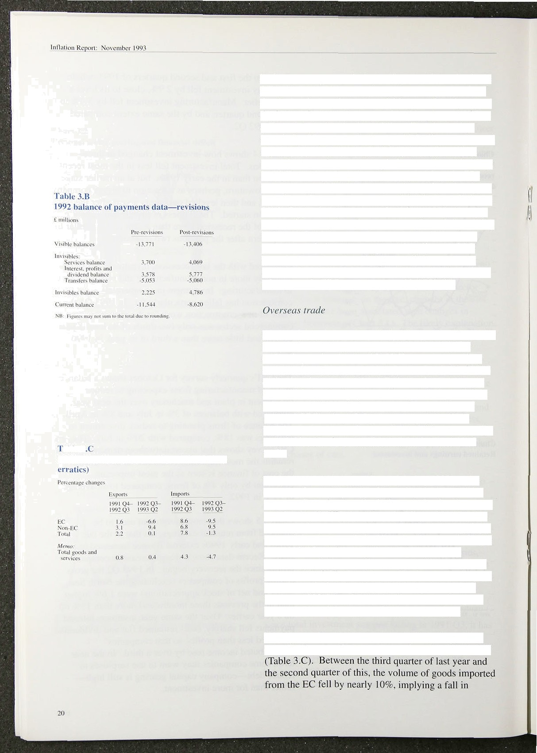

L!lx ti'atle **vt›lumcs in non-oil goods I excluding**

Data revisions have substantially changed the picture for last year’’s current account, while a new system for estimating trade with the EC (VAT returns rather than customs forms) makes the data for the first half of 1993 difficult to interpret. Table 3.B shows the revisions to the 1992 balance of payments data, producing a deficit of 1.4% of **GDP** compared with earlier estimates of

l.99• of GDP. About 0.4 percentage points of this revision is the result of new estimates of interest, profits and dividends; the rest reflects revised estimates of trade.

The balance of trade deteriorated during 1992, as the economy began to pick up, increasing the demand for imports. But, since sterling’s depreciation late last year, and despite the UK recovery coinciding with recession in many of our main export markets, the balance of real net trade has improved significantly. Between 1992 Q4 and 1993 Q2, trade’s contribution to growth, 1.5 percentage points. more than accounted for the overall expansion in **GDP.** Trade’s contribution so far this year has reflected a larger fall in imports than in exports: between 1992 Q4 and 1993 Q2 the volume of exports fell by O.7Wo, While imports fell by almost 5.49».

The figures show that the apparent falls in import and export volumes reflect movements in trade with the EC

D •ni ri I riiir7 ‹ iii Jul

##### CSO trade'figures:, new colleétiiiii methods ’’

Yfiih t1ie completion of the EC single market’at the eh:› t a

.siiñ:of 19S2,.data: oñ, EC.trade flows lean no longer UK :iup»rt p nutr:ition bs areo‹

:be.obtained from cusioms de lârations as in the pasl: “Sin0etli.e. beginriing of the.year,..data on EC trad/e...vâiuis’have.been: based.on the hitrastat. system,.which is linked to the collection of VAT. the:press.notice aecorRpanymg.:the release of the

!latest world:trade stati tics„the CSO acknowledged

thitt"the.Ef!coinponent:of tire figure.has a.greater'. "

ñiargin of epor.and is more subject to::revision than „

the non-EC eompone'nt’.

.

Only partial .information on the,pric*es..of* gopds' imported from and.exported to the EC is,available. from the hitra3tat system.’ As a result, EC prices! are eâlémated by.adjusting non-fiC pnces' ’in‘:an attempt to reflect the divergence in:price moveinents be een ,the two regions. Thé CSO’s.



lafeit.estimates i:i‹Jicate!that the:pnc.es of.non-oil

**.goo‹is** imported .from tlié EC .rose by .14.49b between’1592.Q3 anñ 1993 Q2; non-QC import pnces, over the same.period, rose by 13..4fio. The prices of anon-oil exports to EC’:countnes rose by 9.J&» betweeii 1.992 Q3 arid:lS93 .Q2, compared with an increase.of 7.3' é’ in'tion-EC export prices. Given starling’s.substanfiall:y gre/aier depreciation against .non-EC currencies than EC currencies, thesq import and export price movements are,

;uing„ and may sug est that, ay a re.su1t ofi the. li.mi.ted i.nformafion..ava:lable from.tntrastat,..the prices.of UK.Exports to and imports. from‹tlie! EC ñavo fiean overstated. However, although tire.iiew

.estimated ref pricns.eould be're0ised whén more i4•nfo• •rmati• o' .n. • i• s.y.a' va•ilab• le› f rom• ' ,•th. 'e. In, trasta't . s"I"y*• st' em' . ,



revisions to:prices,.s.hould necessarily .b1e fiownwariio rather than upwards:

These charts suggest that, on eeonoinic. grounds. we would expect afiy future revisiorisl t.o cause both i:nport and particularly export volumes to be revised upwards. Any underestimating of net export volumes would have a different impact depending on .whether it is the result of an underrecording of trade values or an overrécorcting. of prices. If it is purely because of an underrecording of total values’; the .trade.deficit will be .overstated but real .GDP (as measured.by the output index) .is likely to be unaffected. By contrast, if export prices are overestimated:this will mean that QDfi would..fie! underrecorded; beéause

..export defl’ators .are iiow uséd to deflate mafififacturi.rig output:values when\measurin

:rriariufacturi.rig loutput:



Trends in US exy‹›rts‹•›

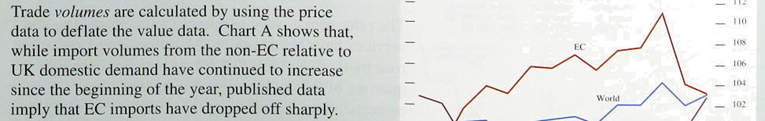



t’t›rPvtu(trttttr und tilzzenCaccounl



peneti’ation of UK markets significantly larger than past relationships suggested would follow from the improvement in UK competitiveness. For UK exports, there has also been a sharp divergence between

_ performance in the EC markets and in the rest of the world. Between 1992 Q3 and 1593 Q2, UK exports



_ outside the EC have risen by 9.4%, increasing their market share. But export volumes to the EC appear to have r llen ne:irly 7%. much more than the slowdown in activity there, despite the improvements in UK competitiveness. One possible explanation is that the new system for estimating trade with the EC has underestimated trade volumes (see the box on page 21).

During the recent recession, the balance of payments deficit was larger as a proportion of **GDP** than in most earlier recessions. Chart 3.6 shows that, during the boom of the late 1980s, the main counterparts to the initial deterioration in the cui rent account were sharp

* moves into deficit by households and companies. The persistence of the deficit during the recession has partly reflected the change in the policy mix towards monetary restraint and fiscal ease. Since sterling’s exit

, from the ERM, the balance of policy has changed. The

* + falls in interest rates and the exchange rate are stimulating overall demand and improving competitiveness: and tighter fiscal policy will serve to restrain domestic demand relative to output. The evolution of the current account will depend on the

, balance between these various effects, and on how

* + - external demand changes. The box on page 23 discusses the measurement of competitiveness, which should be thought of as an outcome of the interplay of these macroeconomic factors.





t ndustr*

Mini i› i in ‹›i I





\¥’ci• lit (Inc quaric r t he ngc in Cltiir gc in

ii i o r›e change in u uipui i o out pm bctwccn

peak





7.2 - I 7.1



**109.0** 0.6 2.0 -

* 1. Ouut ut aannd the out ut aa

The rates of recovery in output in manufacturing and services have been similar. Manufacturing production rose by 0.6% in 1993 Q2, for an increase over four quarters of 2.39c; for service industries, the corresponding figures were 0.69 and 2.4%. But the early stages of this recovery have not been reached by all *sectors of* the economy. Construction output has continued to decline—by 4.3% in the year to 1993 Q2— and is only about five sixths of its peak in 1990 (see Table 3.D).

CBI figures show capacity utilisation in manufacturing has fallen substantially since the late 1980s, but not as

##### UK competitiveness

**.Coñipititiveness is** usually **measure‹i by relative** produce. Althougii cost measure:s.ifiight thâfifoté pnces: or!costs;!e.xpressed in a.common. currency.: be pre(erre‹i..conceptually, they are typically based fiomp9tition in international markets.teiids’to .on relative:,unit labour costs or relat:ive‘:unit wage1. equalise.these prices! attd.costs,. but in the shon costs: (which.do.ri6t9nclufie.non-,wage:!labour

terrfi chaiiges›in.exchange rates‹ean all‹iw th/em to costs).. These vary with the cycle; afid do trio.t/ dJ*erge. Differsncés, in the prt›duct mix and includye noon-labour costs; such as the cost of raw non-price factors, such:as product specitical!on material inputs anda. capital. .Ultimately,.!the choice and. reliability,..can also,affect invitees of of .which. rrieasure of competi.tixeness to just is an coñipetitivenesslin the’longer term, empi!rical .qué'stion.

, Charl.A ’

**Price/cost** competitiveness in u comniiin currency'•'

in the UK real effective:exch;inge rate. aga:inst the other G7

"'"""' i‹ countries on .a.relative unit wage cost hand a relati:xe price basis. As p:result.of sterling’s.



* * depreciation, both tlte price and cost riieasures of competiti.veness have.significaritly iiñproved since
* ' sterling’s.suspension from the ERM (sele Chârt A):

But the improvement in UK corppefitiveness has "' not depended entirely on exchange .rate

movements; in the year to .1993 Q2, unit wag‹i " costs in the United Kingdom fell by aiouiid 49c

, relative to other G7 countries (see Chart B). An increase in competitiveness as a result of lower

_„ domestic costs is likely to be regarded as more ' permanent than a change in competitiveness

cau.sed solely by .fluctuations in the.nominal exchange rate. so it is more likely to .lead to a



”: Measures of. eDmpetiti?eness ñased.on prices.anñ " U l



y '

influence on :théir relative movements: .In a competitii'e market, where. goods



Part.of.the iJifferencei in.

e'p

O•' e

ost effects.

and services. an perfectly substitutable, firms wil'1 be unable.to inflUence.ihe,worlfi price.. A fal!l .in,.

The.United Kingdoom: is emerg:i.rig from recession

:before the major.continental economies,



higlier sterliqy export prices. So this increased Relative prices/e‹›sls' in li›tal cm i viici nn‹1 tlu'

**incentive to supply** for the.export market woulfi efléctix'e **e.tchange** rate

not be reflected .in (co.m! mon currency) relative



prices, which would remain.unchanged, Ho,wevdr,

a

# :e tt ene‘$ woul‹‘i iiaray'›. t e e t ln

i.mpeJecfly competitive kets, firms will be

able to vary tlieir pricés in foreign.eutrenCy te-rms; a fâll in ore.exchange.mte!in this eñse would then lead.to. an.impmvement.iri both.relative co8ts. and

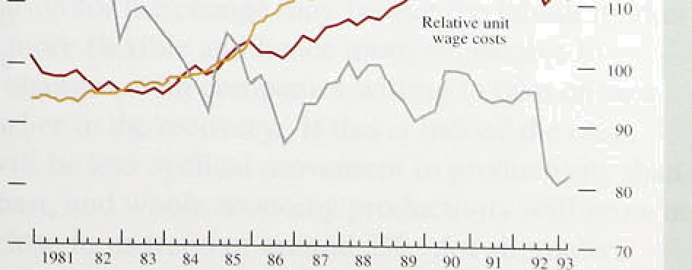

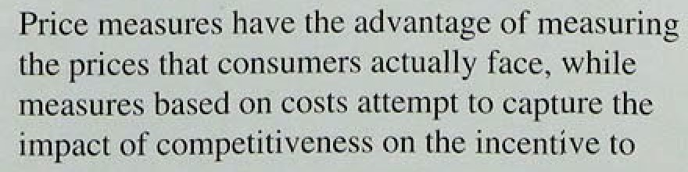



€’ii{›ii citj utilisation **in inaiiufacturigty industry**

I licrccii tuge ‹›l’ respondents at less than t’ull





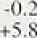

Cwms+no qonJ, 5l 9%7





much as in the previous recession; and capacity utilisation has risen in recent quarters. Table 3.E shows that in October i 993 fi09o of manufacturing firms

i eported that their capacity was underutilised. compared with a mean of 60% in the previous two decades.

Capacity utilisation in consumer goods industries is slightly above the average of the previous twenty years. The main outliers are food, drink and tobacco. where only 37% of firms report capacity being underutilised, and motor vehicles and transport, where over 93% of firms report underutilisation of capacity. The more that capacity utilisation varies across industries, the greater will be the upward pressure on prices (for a given overall level of utilisation) as more firms run into capacity constraints.

The amount of slack in the goods market—the ‘output gap’—can be estimated in various ways from survey results and statistical models (see last August’s

*Quarterl Bulletin,* pages J09-10). Most measures point to a gap at the moment, although the CSO’s coincident indicator suggests the gap has closed.

###### 3 3 Su a

The recovery in output seen so far has been at a moderate pace. The company sector’s own spending has as yet made little contribution to the recovery, though it may do so once the recovery becomes better established and as companies’ balance sheets improve. However, low growth in demand abroad and the expiry of temporary investment incentives at the end of October are likely to inhibit rapid investment growth. The personal sector’s savings ratio has fallen quite sharply from its peak last year, but consumption growth is still lagging behind GDP grpwth. Consumers seem cautious about borrowing. Though confidence may improve with the recent turnaround in the housing market, it seems unlikely that there will be a rapid fall in the savings ratio fuelled by borrowings. After several years of

below-trend output growth, there is scope for above-trend growth for several quarters before the

markets for goods and services start to produce strong upward pressure on prices.

###### s and settlements

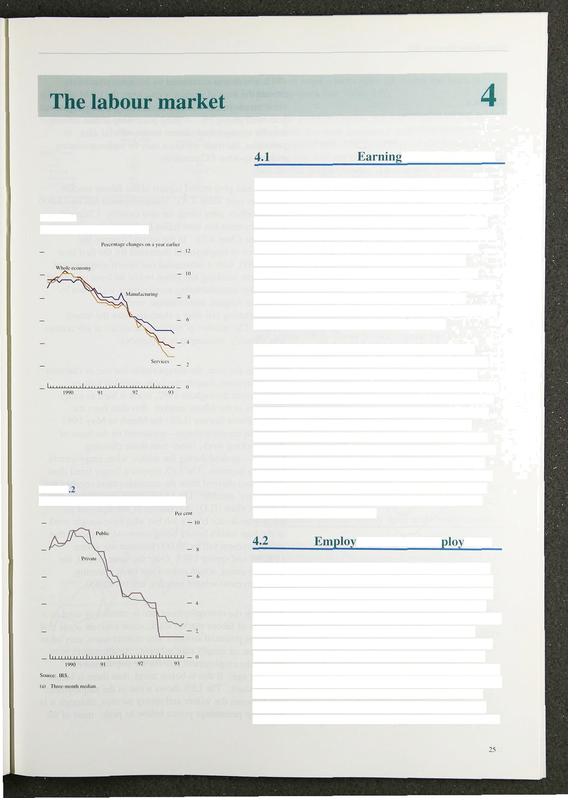

Chart 4.1

**Underlying earnings growth**

Chart 4

**Private and public sector settlementst•'**

In the year to August underlying earnings in the whole economy rose by 3'/i%, the same as in July. well down on the rises in the first quarter of 1992 (Chart 4.1 ). FrOm February to July 1993, the reduction in twelve-month earnings growth came almost entirely from the services sector, but in August underlying earnings growth in manufacturing fell. The Tecently published New Earnings Survey showed that earnings in the public sector rose by 4.3% in the year to April, compared with 4.0% in the private sector, but these figures were

affected by settlements concluded before the I 'liar limil on public sector pay increases was imposed.

The percentage increases in wage settlements have stopped falling. According to the Industrial Relations Service (IRS) measure, the median whole economy settlement declined from 3bn in the first quarter to 2'Zc in the second. rose to 2'/•% in the third. Earlier falls were largely attributable to a bunChing of settlements in the public sector (Chart 4.2). Surveys by the CBI and Incomes Data Services (IDS) are consistent with little recent change in settlements. The most recent IDS data have shown a marked fall in September, but recorded very few settlements. The **CBI** reports that in the three months to July over one in four companies froze their pay, though some have introduced bonus schemes or lump sum payments instead.

###### ment and uneni ment

Employment has started rising sooner after the turning point in output than it did in earlier cycles. In the early stages of the previous two recoveries, employment was still falling a year after output had begun to rise. One explanation for the change may be that the labour market is now more flexible and hence more responsive to output changes, with companies willing to take on new staff earlier in the recovery. If this is indeed the case. there will be less cyclical movement in productivity than in the past, and whole economy productivity will grow at a rate close to its trend of around 2&o. An alternative explanation is that the recent rise in employment may represent a reversal of sentiment after the fall in Autumn



1992, which was stimulated by business pessimism around the time of sterling’s exit from the **ERM. On** this *vie w,* employment will rise further only if output growth goes well above 2%. A third possibility is that activity may be stronger than shown by the official data; in particular, the trade statistics may be underestimating exports to other EC countries.

Recent data give mixed signals about labour market pressures (see Table 4.A). Unemployment fell by 13,600 in September, after rising for two months. Claimant unemployme nt has now fallen by 84,000 since January 1993 (see Chart 4.3). In the second quarter, the workforce in employment increased for the first time since 1990, with a substantial rise in self-employment.



Short-time working has fallen below its level in August 1989. But manufacturing employment was down by 24,000 in August, and overtime working in manufacturing fell after a sharp increase the month before. The number of unfilled vacancies at job centres was virtually unchanged in September.



Earlier in the year, the abrupt end to the rise in claimant unemployment, despite the large recorded falls in employment throughout 1992, made it hard to gauge pressures in the labour market. But data from the Labour Force Survey **(LFS)** for March to May 1993 show that unemployment—measured on the basis of those seeking work, rather than those claiming benefits—peaked during the winter, when employment began to increase. The LFS reports a firmer trend than do the data derived from the unemployment register and employers’ records. The LFS follows the International Labour Office (ILO) in counting as unemployed all those who do not have a job but who have sought work *in* the four weeks before being surveyed. It shows that unemployment fell by 90,000 between the winter 1992/93 and spring 1993. Over the same period, the claimant count, which covers just those claiming unemployment-related benefits, fell by 40,000.

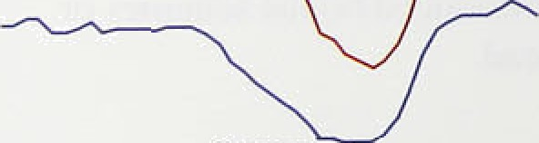

 Although the unemployment rate is commonly used as a measure of labour market slack, some analysts argue that it ignores potential workers who instead retire, stay on in education, or simply stay at home. An alternative is to look at the employment rate for the population of working age; if this is below trend, then there is labour market slack. The **LFS** shows a rise in the employment rate between the winter and spring surveys, although it is still three percentage points below its peak; most of the

2f›



# T**'*«.a

. . ’

**£sbour fqree auzway: cbnayes zn emplo.ynsent**



,Spring.;l9' ' 'Winte'r. l9.92f9.fl—





Chart4:%

VhoIs‹xooom cmd fit}:intWorzxséons:





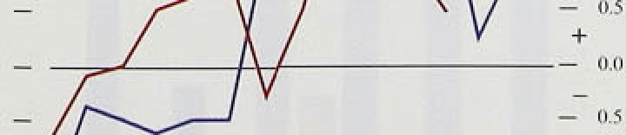

growth in employment since the winter has been in pan-Anne work (see Table 4.B).

As in the l98(ls .recession, the rise in unemployment

.sifice .1590 has been associated with a fall in the ‘panicipation’ rate the of the population of



who are either in work or loot ng for it. In part the fall may .represent ‘discouraged workers’, with people!ceasing to look for work as unemployment rises. But the figures probably overstate the fall in the participation rate during a recession, for two main



.reasons. .First, some of those with two jobs (about 4% of those i!n.employ.ment) may lose one of them, causing the job count to fall without adding to the unemployment count. Second, some of the rise in unemployment during a recession will involve people who, for a variety of reasons, do not claim unemployment related benefits.

.Figures from the .Labour Force Survey point to a rise in non-claimant unemployment of 90,000. equivalent to 0.2% of the population over 16, between spring 1990 an‹i spring 1993. These factors suggest that the 'true’ participation rate fell by only 1.6 percentage points, rather than 2 percentage points. In the mid-1980s, the participation rate rose once unemployment began to

.flatten›out, and continued 1to rise until 1989, when unemployment was close to its trough. As the economy recovers from lthe recent recession, the participation rate may,.rise again, as the number of people with two jobs

.rises, .an‹i ‘discouraged’ workers decide to re-enter the

)ob rrrarket. This suggests that the measured unemployment rate may understate the degree of slack in

.labour market, and therefore understate the scope for

**an‹i** before wage pressures begin to mount.





.Productivity .growth‘has been much stronger during the recen(recession than in previous downturns (Chart 4.4). In!the early.stages manufacturing output fell around half as .quickly as.i.n the 1980s recession; but employment

**at!muCh** the:same rate, so productivity behaved quite



:In:the fouith qiiarter of 1980, manufacturi.ng produfitivity was about 8% lower than a year earlier; by **centrait.in** the :year to 1:990 Q4 productivity fell scarcely at.all, bécause employe i reacted1.sooner and more fully to the!fall in. output. ,In both:!recessions, productivity grew strongly whén loutput began to recover. However, it was clo r to trerid/ in.the 1990s: recession than I.n the I980s one, leavi!ng less.ground to make up. For ez8mp1e,.short-nme Working is lower now than.:at the Operable stage in..the,.1/980s cycle. and overtime per

27



d’alile 4.C

InIl DiflUl folly tif Oilrnings and prpdtiptjs'jty tp ttjyJt







Lumpur Employment Lab'our Eamiiigs .Unit u.'yc

'pmducti'iity per employs.ecosts '

1990 (j.9 0.7 -0.1 9.9 9:8







I 'J')2 Q I -?.') -f›.0 3.7 :8:6. 4.7

worke.r is hi.gher. Tliis means.that!lthe pace of pro‹iuctivi.ty growth may, not be”sustained for.as long as it was in .the early l980s1. Indeed, the’latest‘monthly data for manufacturing sliow.:that tlie annual increase.in



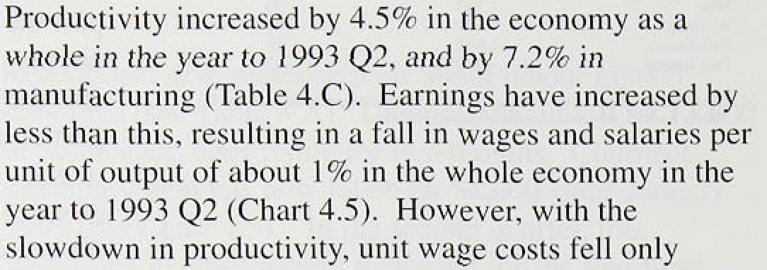

unlikel.y to regain the pace.achieved.:at the beginning of thisl year, unit labour.costs wih:.stop fall:ing; though.they ar.e.unlikely.to.rise by. much.



Monthly fiaia

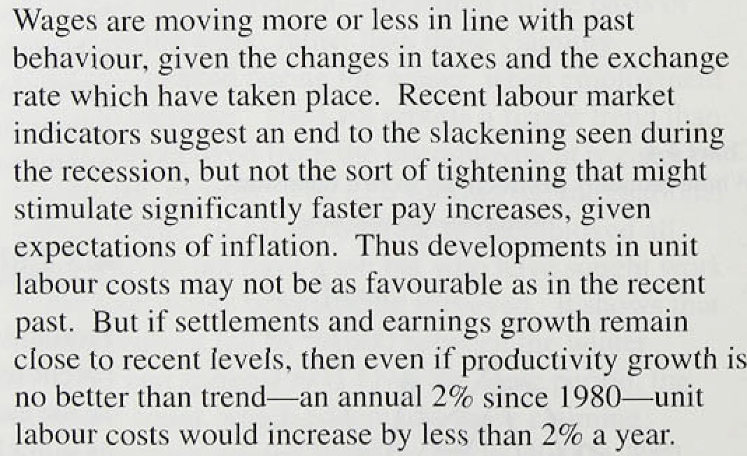However, they con.tiriue to .fall relati.ve to.those! of the United Kingdom’s major competitors. In. Germany„for example. productivity has..been falling. and!unit.wage. costs have been iising:sharply.





28.





**External influences**

*Primary product f›!rices*

Primary products (including fuels) comprise about one sixth of UK imports, with industrial materials (agricultural non-foods and metals) making up three quarters .of UK non-oil commodity imports and food the rest. Commodity prices may have a short-run effect on



.UK inflation, though in the long run it is determined by domestic monetary policy.

Commodity prices have dropped back in the last eight months, having risen sharply in sterling terms from September 1992. Sterling’s depreciation last year, especially against the dollar, together with stronger timber prices, contributed to a rise of nearly 40% in the UK-weighted non-oil commodities index between 1992 Q3 an‹i 1993 Q1. Since then, stefling has risen. and tiinbér prices have fallen, as. worries about the cost implications of US environmental policy have eased.



This .has offset slightly stronger food prices (reflecting in part the introduction of a coffee producers’ withholding

.scheme). Sterling UK-weighted non-oil commodity pr1ces.fell by'7.1% in Q2 and a further 4.2% in Q3 (see Chart 5.1). lii the near term, there is only a small risk of significant .increases in non-oil commodity prices.



Despite the .introduction of the coffee scheme, similar

1. p,„¿, ,agreements between suppliers of industrial materials

,(which, have a large weight in the UK index) remain

- • unlikely. Other factors. such as large stockpiles

’: -:y : (Chart.5.2) and the weakness of world demand, are likely

.; . to, matter. more:.

Sterling si.I giices were stable in the first half of 1993, then fell in lthe mirror quarter. Dollar oil prices were lower as a res::1:t..of ñoiitinued prodliction above quota by OPEC members, poorer:prospects **for.deman;i** and a favourable response’io.peace moves. in the. Middle East, which may lielp to.safeguard lon'g-term oil supplies. Prices



million barrels a day million barrels a day above the

**qupta wi!ll b.e exceeNd;** ’botli **K.uviait** arid **Iran** have

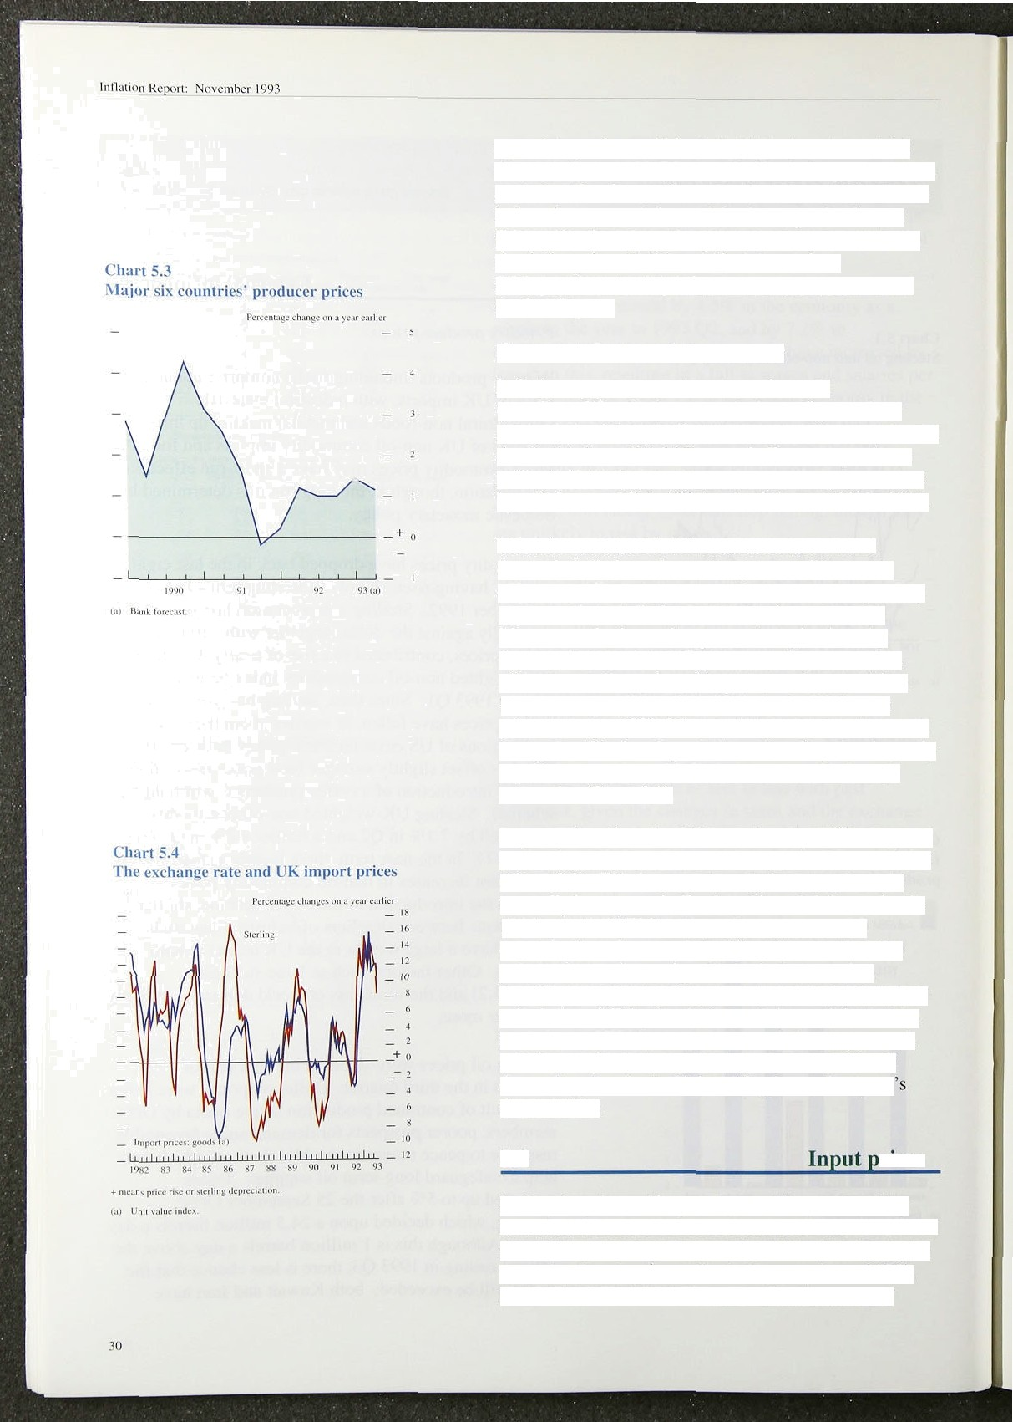agreed to produce within their (higher) quotas, which they did not in 1993 Q3. Further, the new quotas, which are to last for six months rather than the usual three, are below the expected demand for OPEC production, as forecast by the International Energy Agency. Even so, the dollai’ price of oil has drifted down since

30 September, leaving it 2% lower than at the time of the last *Reporl.*

*O\’ei.sea.s iiij'Iminii curd imj›‹›i i )›i ices*

Inflationary pressures abroad remain weak

(see Chart 5.3): for instance, the latest figures show producer's’ prices actually falling in Japan. According to the Bank’s latest World Economic Forecast, producer prices in the major six economies are likely to increase by a little over I % in 1993 and a little over 2% in 1994.

There is no automatic link between overseas and domestic inflation; the exchange rate will move to offset the differential, unless domestic monetary policy accommodates inflationary shocks from overseas.

Movements in the exchange rate brought about by changes in monetary policy at home or abroad often *a*ff*ect* the sterling price of imports much more. Thus 12 percentage points of the 14% rise in UK import

prices between 1992 Q3 and 1993 Q2 can be accounted for by the effective depreciation of sterling, leaving only 2 percentage points to inflation measured in foreign currencies (Chart 5.4).

Import prices from the Efi have risen by 14% compared with a depreciation of around 8% against EC currencies (Chart 5.5). This increase is well above what would normally be expected. Further, Chart 5.6 shows that in 1993 recorded UK import prices from other EC countries have increased significantly more than the prices of manufactured goods in those countries.

Despite recent improvements made by the CSO in their calculation of EC price deflators, it is possible that the statistics on UK import prices have been exaggerated, which would help to explain the muted response of domestic prices in the United Kingdom to last year depreciation.

### 5.2 rices

So far, the prices of imported materials purchased by manufacturers have increased much less than the official data on import prices suggest—by 59 in the year to the second quaner. against a rise in import prices of 13%.

In the twelve months to September, manufacturers’

Chart 5:5

**The stei•1ing:ezcfiangii rate and import prices:**

. (1992 Q 1993 Q2),





imported input prices rose by 5.2%. Prices of manufacturers’ purchases oflhome-produced materials increase‹i.by .3..loo in!the.twelve .months to September, whereas prices pf.thei.r fue! purchases fell slightly (0:4fir). The twelve-.month increase in .manufacturers

, total input costs was 3.5%. in'September 1993, compared  with!1.6.3% i.n August. The steep rise in input prices seen

.last autumn is n0W starting to drop out of the twelve-month comparisons.



.F.ood prices in the United .Kingdom covered by the Coinmon Agricultural .Policy are in.fluenced by the green poufi‹i the rate at which the EC agricultural support is converted into sterling. But, it was only at the end of Decernbér 1993 that .the green pound was brought into line with the £/DCU rate following the depreciation of sterlihg. Consequently, changes in food input prices

ta) Based **oi thr ma-bCmirriiicie,** r 'the sieriing.i:dix oiia5'ifi folly:ing wcighii: lagged lbehind movements in the rest of the index.

 reen pound are now made regularly



'P pcc in cren8s caiculoti d trem'dz!o su tili.i4i'ed’ 0n 2 I..Oc.tome.r: °!Ec nna'w eyid iinPo n.



to keep the rate in line with the exchange rate, so this

ps **Busin**ne**es**s**s**s **r**ro**ofita**a**bilit**

returns on capital depend on how prices move

:relative to costs and to what extent capital is mil ised.

* i :-...i ii . Chart.5.7 shows that. the real return on capital of non North Sea industrial and commercial companies **(ICCs),** w!hich.!peaked before the recession began in 1990 Q2, fell

’.“ sharply to ñ:2% in 1952 Q1.. It has been rising si.nce. '. , The trough in ICCs’ profitability during the recent

recession was not nearly as deep as during the recession

„ of tire ,early ! 980s. The return on capital is now above ii” the'average.level over the last twenty years. It is not yet

« .clear..\whether this reflects higher rates of return required

* + iñ. the !ong run; this will depend upon real interest rates iq...the .world capital market, which reflect the global balance, of savings and investment..

Chart.3:8 sho.ws. a fiistoricall:y close. relationship between

* . All:tCCs '

d their capacity utilisation.

Howev.er,. ;during..the:boom of:the .late .1.980s, and particularly during: the subs!equent .recession, this link weakene:d and:..p fitability varied less, for two main reasons. First, finns:. have adj'usted their.labour inputs quicker in:the .recent.recession thâir in e.arlier periods.





coinpetitiyeness deteriorated:much less in:.the l990s

* i1 recession thafi i.n{tEe..early l980s„!soitiiat there, w:as: much less ‹downward'pressure on f!rins’ grofit mtirgi:its. .!



gust*l-9,93., “.Company



**pages**

3’I,'

’

lnflmitntR0p*fl: NwvQnibcFl99j_ _

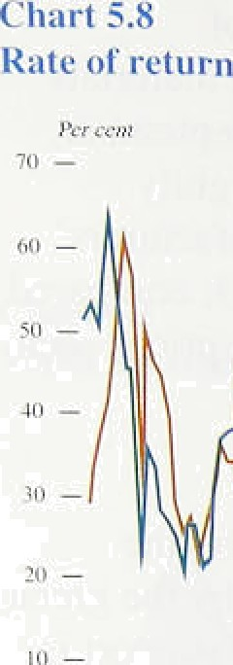An increase in profitability during an upswing is not

**on ciipit:il and capacity** utilisntioN necessarily inconsistent with progress in reducing

•••= inflation, because higher profitability may arise from " increased utilisation of capital rather than from any

increase in prices relative to cost. Chart 5.9 shows

trends in the rate of return on capital for non North Sea

, ICCs, and the ratio of profits to cost. The profits to cost ratio is more stable than the rate of return or the capacity utilisation measure and has varied less during the recent recession than in previous cycles. Since the mid-l980s

* + UK import prices have increased much more slowly than consumer prices. This has allowed real wages to

 increase in line with domestic productivity, as well as a

rise in the share of profits in GDP.



**Chart 5.9**

**Ralios o1’** profits **t‹i capital and protits ti› costst*'**





**l’able 5.A**

**Conlributions‹•› to ni:inutacturers’ output price**





1992 1993

i I.ah‹›ur proJuctiviI\' 2 1 ?.2 2.7 3.5 3.2 2.4 I.V

2 I.ab‹›ur «usis 2 7 2.8 2.2 2.3 2,4 2 0 I.3

f?'=2 I ) ‹›.1 0.0 -0.S -I .2 -0.6 -0 4 -0.6

4 Input pnces -0.7 I.2 0.7 I.8 I.4 1 9 * !

i BuyNins vi<x•‹ 1? !0 0.7 R! -0.2 •O.3 -0.4

I .2 2.0 I .3 1.4 2.0 I .3 I .6

A reduction in gross margins was to be expected after a depreciation which increased the prices of purchased inputs. But firms should focus on their return on capital, which depends on capacity utilisation and unit labour costs too. Table 5.A shows how manufacturers’ output prices have changed. Following sterling’s depreciation last year, the contribution of input prices rose sharply.

But it was offset by falling unit labour costs and a slowdown in the rate of increase of prices of bought-in services. As a result, manufacturers have been able to rebuild margins while output price inflation has been stable at around 2'/4%. The CBI’s October Industrial Trends Survey shows that a (seasonally adjusted) balance of 4% of firms expect to increase prices rather than decrease them in the coming four months. This compares with a balance of 5% in July.

Although some of the effects of last year's depreciation have still to work through to prices, the immediate effects will start to drop out of twelve-month comparisons in the next few months. However, as noted in Section 4, productivity increases are often largest in the early months of recovery, so that unit labour costs may soon become a less benign influence on cost pressures, The extent to which companies have managed to defend profitability during the recession means that margins may make a milder contribution to inflation than in previous recoveries, though there are important sectoral differences.

7 Ompulgn‹wsc



32

z. z.3 2.2 2.3 2.3 2.4 2.d

*Pr’ce dvnnniics*

### :5 4 S a

World commodity prices are likely to be held in check by weak world demand and large stockpiles, so it is unlikely that .upward pressures on firms’ prices will emerge from thfs direction. Nor should the rebut Jding of profitability after the recession be a problem. ICCs’ return on capital has been rising since 1992 Ql and is already above the average for the last 20 years. Spare capacity has not reduced profitability to the extent it has done in the past. Increases in the prices of imported inputs have been offset by reductions in unit labour costs in manufacturing, so it should not be a cause for concern that the ratio of.output prices to input prices has fallen.

33

6





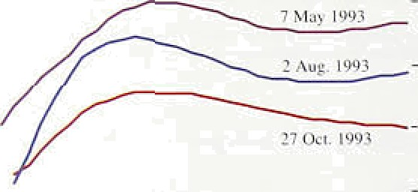



(.’ he rt b.2

€’i›rnJi:irison ot' k I'I X inflict inn l’urecasts for



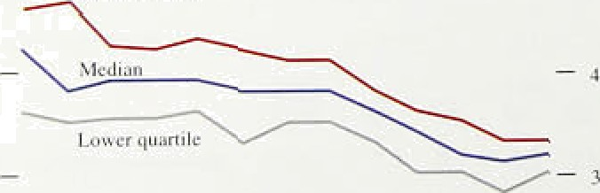





34



During the two years that sterling participated in the ERM, inflation expectations declined significantly. But they rose sharply after sterling left the ERM in September last year. The new framework for monetary policy announced in October 1992 was designed to help restore credibility. This section first reviews developments in inflation expectations and then presents the Bank’s own view of the prospects for inflation to mid- 1995.

#### Evidence from financial markets

The previous two *Reports* have described how the term structure of expected inflation can be estimated from yields on conventional and index-linked gilts. There was a marked rise in longer-term inflation expectations following sterling’s departure from the ERM. By December 1992. annual inflation was expected to be some two percentage points higher in around ten years’ time than had been expected in early September.

Movements in gilt yields suggest that expectations remained around these higher levels until the spring of 1993, and it was onJy in the early summer that there was any sustained decline. Expected inflation in around ten years’ time fell by over one percentage point between early May and early August (see Chart 6.1). The fall continued into October, bringing expectations down close to where they had been before stealing’s exit from the ERM. Provided there is some risk premium on conventional gilts, these figures suggest that longer-term inflation expectations now lie within the Government’s 19 —4% range, though they do not yet indicate full faith in price stability.

#### Private sector forecasts

Forecasts produced by private sector organisations such as City firms and academic institutions indicate how their perceptions of future inflation are changing.

Chart 6.2 shows the median of 36 private sector forecasts **of RPIX** inflation in the year to the fourth quarter of this year, as recorded each month since October 1992. (Half the forecasts are higher than the median, and half lower.) It also shows the upper and

lower quaniles (one quarter of the forecasts being above the upper quartile, one quarter below the lower quartile). Last winter the median forecast remained near to 4%, with the majority of forecasters concerned that the depreciation of sterling and higher import prices would put upward pressure on RPIX inflation. As these fears have abated, forecasts have been lowered; and their spread has naturally narrowed, as data for more of 1993 have become available.

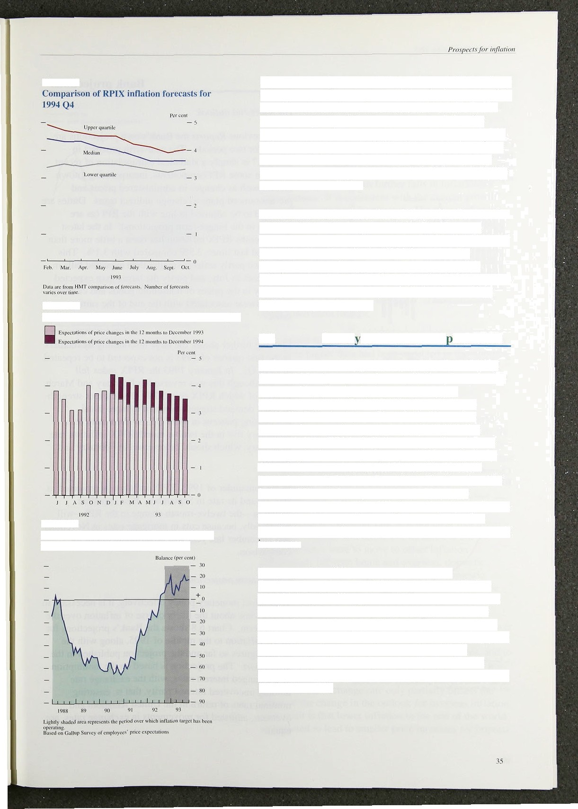

**Chart 6.4**

**Smith** New **CourVGallup** Survey Of fund managers

**Chart 6.5**

**Balance of employees expecting annual price inflation to be less than or equal to** 4 No

Chart 6.3 shows the evolution of the median forecast for **RPIX** inflation for the year to 1994 Q4. Here too, expectations have been falling during this year, although not quite as much as for the 1993 forecasts. By September, even the upper quartile was within the Government’s target range for underlying inflation, even though most forecasters expect inflation to be a little higher next year than this,

* 1. **Surve** s **of inflation ex ectations**

Perhaps not surprisingly, the Smith New Court/Gallup Survey of fund managers shows a similar picture to that suggested by gilt-edged prices: that inflation expectations rose in October of last year but have gradually fallen back (see Chart 6.4.) Most other surveys also recorded a jump in expectations after sterling left the ERM. A Gallup survey of employees continues to show a majority expecting inflation to be 49c or below over the next twelve months if ‘don’t knows’ are excluded (see Chan 6.5). The October CBI Industrial Trends Survey reveals that 729c of its respondents are expecting their domestic output prices to remain the same over the next four months, and the remainder are nearly equally split between price cuts and

increases.

A survey with a different pattern is Dun and Bradstreet’s, which asks managing directors whether they think their selling prices will increase or decrease. As **Chan** 6.6 shows, the surveys undertaken late last year had substantial majorities expecting to cut prices. but by the summer of this year a small majority expected their selling prices to rise. And according to an EC/Gallup Survey, consumers are more pessimistic abput inflation prospects than at any time since February 1991 (Chart 6.6).

##### Bank

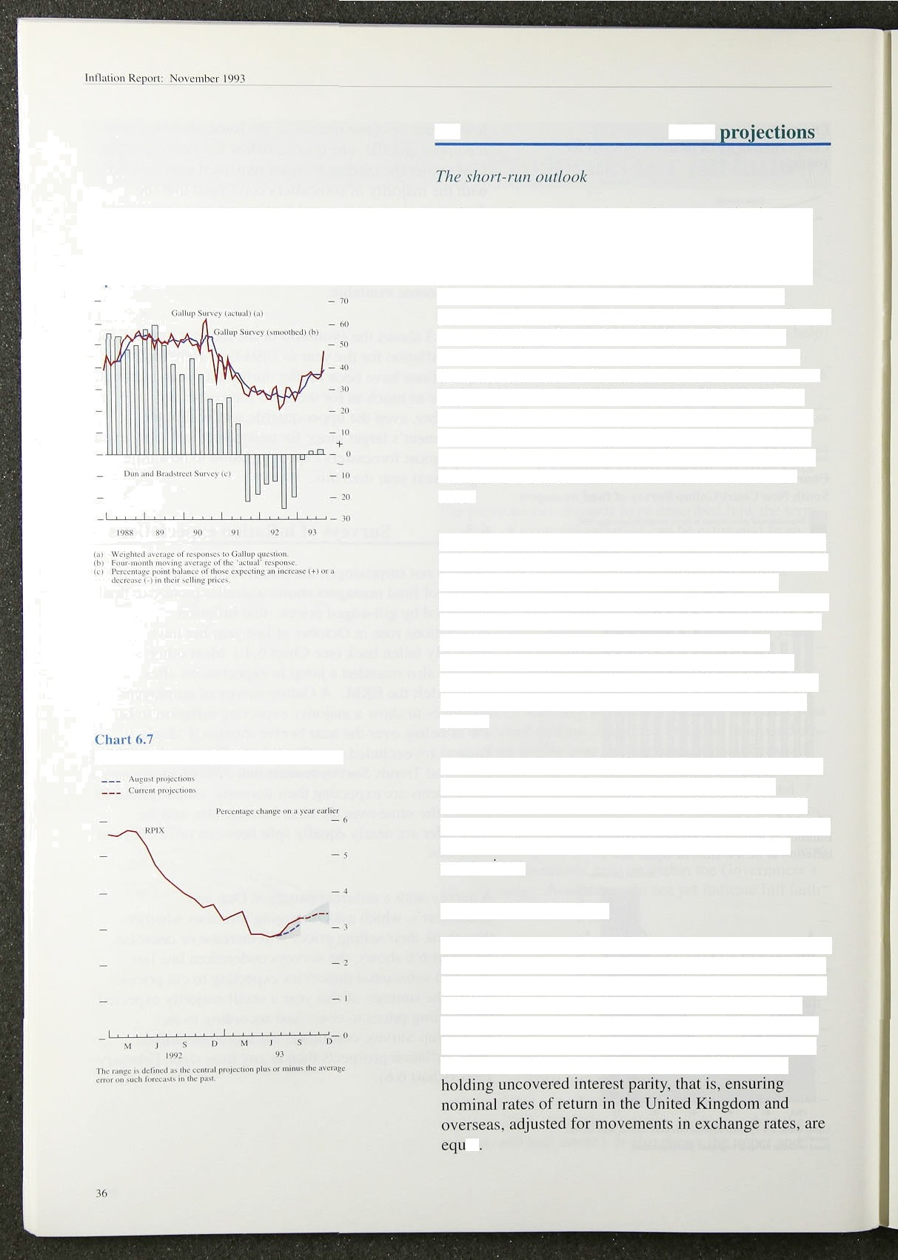

t’liart I›.6

Dun rind **llradstreet** Survey on expectations ct’

selling prices rind **1'?C/mall up cnnsumcr inflation**

**ItPIX inl1atioi› pm)ecti‹›ns ancl outturn**

As in previous *Reports* the Bank’s own projections are shown for two periods. The near-term prospect in Chart 6.7 is simply a statistical extrapolation of recent trends in some **RPI** components, incorporating known factors such as changes in administered prices and

pre-announced plans to change indirect taxes. Duties are assumed to be adjusted *in* line with the RPI (as are benefits in the longer-term projections). In the latest three months RPIX inflation has risen a little more than projected last rime: 3.3&o compared with 3.1%. This difference partly reflects smaller than expected falls in food prices in July. and partly the larger than expected recovery in the prices of household goods and clothing and footwear associated with the end of the summer sales.

Looking further ahead. the large discounting by retailers in the first quarter of 1993 is not expected to be repeated in 1994 Q l. In January 1993 the RPIX index fell 0.5%—though this was reversed in February and March, in each of which **RPIX** rose 0.7%. The current strength of retail demand suggests a return to more usual discounting patterns in 1994 Ql ; so there may be a temporary rise in the twelve-month **RPIX** inflation rate in January, which should be reversed in February and March.

In the remainder of 1993. **RPIX** inflation is projected to stay around its rate in September. If so, headline inflation—the twelve-month change in the RPI—will rise rapidly. because cuts in mortgage rates in November and December last year will be dropping out of the comparison.

*Longer-term projec’tions*

To conduct monetary policy effectively, it is necessary to form a view about the likely course of inflation over the longer term. Chart 6.8 shows the Bank’s projections for RPIX inflation to the middle of 1995, along with the actual figures so far and the projection published in the last *Report.* The projection is based on the assumption

of unchanged interest rates, with the exchange rate

at



c»t+> The.projection for RPIX is little changed from three months ago. Ttte most likely path is, for a small rise until the first quarter!of next year, peaking at an annua] rite above *3'/zSa.* After that .RPIX .inflation is likely to fall gradually. Excluding changes in indirect and local authority taxes, it may fall to around 3% by the middle



,of 1955. This ref)ects!the:continuing high level of unemployment and the shortfall in output relative to its potential, combined with further falls in inflationary expectations. .It is consistent with the current growth rates. of the:rnonetary aggregates. The revisions to the

;Bank.forecast1.have been smaller this ti.me than they were three months ago, because the economic news in the last quarter has been less surprising than the news received i!n the.previous quarter. However, Chart 6.8 shows tliat RPIX inflation .is now expected to be a little higher.until the en‹i of 1994 than was expected in August, and a little lower thereafter. These changes reflect two main factors:



a recent figures for underlying inflation have been a littlé higher than had been expected in the summer, when it was still uncertain how far price cuts

.associated with the sales and seasonal foods would be! reversed;

*.N* projections for the level of.demand in the world

.economy have been revised downwards repeatedly

:by riiost forecasters, including the IMF and OECD.

’’ Subject to the exchange rate assumption, this means that the demand for British exports will be lower

” towards the end of the forecast horizon, and the

.output gap higher.

” With a floating exchange rate, it is not clear that lower inflation overseas will affect UK inflation at all. If exchange rates were to move to offset inflation iiifferetltials between home and .overseas, domestic developinents alone would determine the domestic

. inflation rate, and the real exchange rate would not be

.afiecte:d by nominal lshocks. In this forecast, however, the exchange rate ldevelops according to uncovered interest.pârity. The newsl that real output abroad is lower than.had been expected .means that real interest rates overseas.are likely to be lower .than .UK real rates, and to remain sci,for the rest’of the forecast period. There has been a deJlationary shork in Hurope, and tlie resulting change in the exchange rate only partially offsets the effect e the.chatigé ’in ‘tlie outlook for overseas inflation. The uli.is that lower.i.nf1ation .in:the. stiof the world is expected to lead to smaller price increases..for imports



h+aionRtgwH: Novmha_l093’

from the middle of 1994, and sterling's.real exchange rate is. expected to rise a 1i!ttle, given tlie’assumptions of the projecti.on. The fee‹i-through from worl‹i to..UK inflation is not one for one. but it is large:enougii to generate the slight fall in inflation we see in 1994 i-12 and 1995 H1, .compared with!.the essentially flat profile.. presented in the last in//nfion *Report..*

t/ncerf *ainties*

.Our projections will soon ,start to cover prospects for achieving the lower hal.f of the I.&rW% target range!for RPIX .i.nflation by the.end, of’.the..Parliament. .B,ut various uncertainties will have a considerable effect on the path of inflation even before that. The first concerns the exchange rate. This will depend on interest rates abroad as well as in the United Kingdom. On the whole; otlier EC countries have been .reluctant to see big depreciations of their currencies sinee the demise of .the narrovilband

of the exchange rate rneehanis'm, so int‹irest rates’ arel falling only as fast as they are cut in Germany. Overseas interest rates will .also be influenced by the level!of activity, which has been weaker than most observers expected. If attempts .«i stimulate recovery .lead to bigger than expected ‹ruts in interest rates, this would be likely to push up the sterling exchange .rate and reduce inflationary pressures in the short .rim.

A second source of uncertainty is the bqhaviour pf wage bargainers. If firms and employees, believe that inflation will remain low, then any target level of .real .wages will be associated with lower nominal wages, an‹i prices .than otherwise. But it is possible .that the increases in headline. inflation.likely .i!n. the next!.few .months.may slow down the revision of!i.nflauoriary expectations. ln which case, there is a.dan'ger tiiat wage bargainers, will settle .for excessively high .nominal wages,:.fol1owéci .by increases in producer prices unwarranted by the stance of monetary policy. It nee‹ia to be properly .understood that one-off boosts to the.level of prices, .for instance from higher indirect taKes, do not mean any slackening

of anti-inflationary .policy, and should not be’regai‹ie‹i,as, permahent increases, in the underlying rate of inflation...





Since the August *Aeport,* most twelve-month measures o(iriflation have risen. Headline inflation has gone up from 1.21c to 1.8& ; **RPIX** inflation from 2.8% to 3.3%: and inflation measured by an index which excludes both inortgage imerest payments and taxes from 2.8% to 3.S%. There were two main reasons behind these rises: in June, retail discounts were unusually large and

!widespread, and food prices unusually low, whereas

. .,between June. and September discounts fell and food price inflation rose. It was unclear in August how far

.these effects would unwind. The higher price level will lead to a higher twelve-month inflation rate than was expected at the time of the August *Report,* until the

:effect drops out of the index in the middle of 1994. But it does not imply a higher rate of increase Of prices *In*rther into the future.

Giyen.current policies, the Bank’s view of the most likely outturn is that inflation—both headline and RPIX

—will rise until the .middle of 1994 and then start to

.decline again.. The new information available since the August *Report* has led to a small upward revision in the twelve-month inflation rates expected over the next few months, but it has not produced any significant change to the expected rate .of inflation two years from now. The central projection remains within the target range for RPIX 'inflation. But there is a slight possibility that in the first half of next year inflation will briefly rise above the top of the target range. This is partly because of changes in indirect and local authority taxes. Excluding these taxes, inflation is:expected to.start falling in early

.l 9.94,.and cou!ld reach a.level close to the middle of the target rangg in. 1995. Headli.ne .inflation will rise

.particularly sharply as past reductions in .mortgage interest payments fali out of the twelve-month co.mpaiison,.an‹i mortgage interest relief is restricted from’next April.,

Su'ch!.prqjections are inevi!fably subject to a large margin of.error. What, matters.is .the dfiection in which inflation it headeti. There âre particular.uncertainties associated wtU a, pfoé1e.of inflation that first rises!!and then falls,





beaus.that may,affect,longer-term expectations of E@ finns of ififlation can have la



lnflu1i,iu RcQon: NovcpiMrlo 3

increase in inflation is simply extrapolated *ID*iWfif‹i añd, earnings start to: rise more rapidly, then r ore of the growth of nominal .demand w0ieh is.expected over the next year or two will take the form of 'higher prices rather than higher output and.employment:. But if!the rise in the published.inflation rates is perceived.as temporary, then the.monetary sta!nce will be consistent. with lower inflation and stronger output.

For this optimistic i›utcome to be achieved, rfiuéh wfll depend on sustaining the credibility of anti-.inf1ati.onary policies. The continuing output gap, moderate growth of nominal demand, and slow growth in.broad money and credit, all point to.the possibility .of.bringing

inflation down further at the sâme .ti!me:as. output growth picks up. And evidence from the yield curve suggests that expectations of inflation in .the medium and Ion!g term have fallen again over the past.quarter,.reflecting growing belief in the inflation target: Implicit in! that1!is a market expectation that the Government ivi:I.l steadily. reduce the budget defici.t. This perception is crucial, because a substantial rise .in! the ratio of.national, debt to national income would lead to fears. that the burden of debt would one day be .monetised.

40



Reprinted from the *November* Bank of England Quarterly Bulletin

Price E4.00